**Configuration of Prometheus and Grafana on AKS Cluster**

**Introduction to Prometheus & Grafana**

**Prometheus: -**

[Prometheus](https://prometheus.io/) is an open-source system for monitoring and alerting. Prometheus collects and stores its metrics as time series data, i.e., metrics information is stored with the timestamp at which it was recorded, alongside optional key-value pairs called labels.

### **Features**

* a multi-dimensional [data model](https://prometheus.io/docs/concepts/data_model/) with time series data identified by metric name and key/value pairs.
* PromQL, a [flexible query language](https://prometheus.io/docs/prometheus/latest/querying/basics/) to leverage this dimensionality.
* no reliance on distributed storage; single server nodes are autonomous.
* time series collection happens via a pull model over HTTP.
* [pushing time series](https://prometheus.io/docs/instrumenting/pushing/) is supported via an intermediary gateway.
* targets are discovered via service discovery or static configuration.
* multiple modes of graphing and dashboarding support.

**Following are the main components of Prometheus:**

* [Prometheus server](https://github.com/prometheus/prometheus)
* [Client libraries](https://prometheus.io/docs/instrumenting/clientlibs/)
* [Push gateway](https://github.com/prometheus/pushgateway)
* [Exporters](https://prometheus.io/docs/instrumenting/exporters/)
* [Alertmanager](https://github.com/prometheus/alertmanager)
* various support tools

Following is the architecture of the Prometheus.

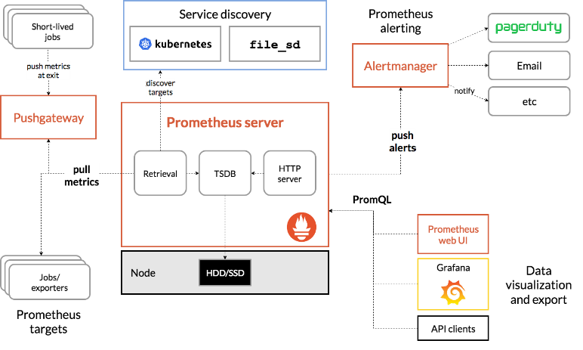

##### **Grafana: -**

Grafana is an Open-Source data visualization tool. We can connect different data sources to Grafana and create meaningful, rich dashboard for different workloads. In Grafana we can connect different data sources like Prometheus, inflexDB, Elasticsearch, Azure logs, collectd.

**List of Contents: -**

**1. Setup Azure Managed Prometheus and Grafana**

**1.1 Create a Managed Prometheus instance using the Azure portal.**

**1.2 Create an Azure Managed Grafana instance using the Azure portal.**

**1.3 Configure managed system identity for Managed Prometheus and Azure Managed Grafana.**

**2. AKS Metrics collection**

* 1. **Create Prometheus data source in Grafana dashboard.**
  2. **Collect Prometheus metrics from an AKS cluster.**

# **Monitor the Azure Kubernetes services in Grafana Dashboard.**

**3. Application Monitoring and Alerting.**

* 1. **Deploying the web application routing sample application**
  2. **Visualizing the Prometheus Dashboard in Grafana.**

## Create Grafana Custom dashboard.

* 1. **Replicate the dashboard across clusters.**

## Create the Alerts in the Grafana Dashboard.

**4. Unified Grafana Dashboard.**

* 1. **Visualizing the metrics in same subscription same region of monitoring workspace.**
  2. **Visualizing the metrics in same subscription different region of monitoring workspace**
  3. **Visualizing the metrics in different subscription.**

**5. References**

**1. Setup Azure Managed Prometheus and Grafana**

**1.1 Create a Managed Prometheus instance using the Azure portal.**

1. Sign in to the [Azure portal](https://portal.azure.com/) with your Azure account.
2. In the **Search resources, services, and docs (G+/)** box, enter Managed   
   Prometheus and select **Managed Prometheus**.

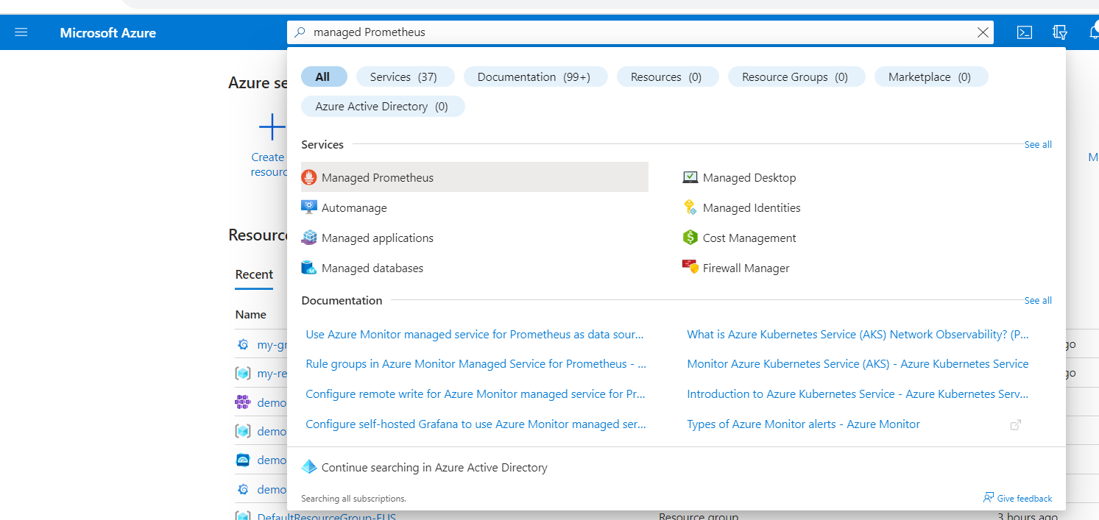

1. Select create.
2. On the **Create an Azure Monitor Workspace** page, select a **Subscription** and **Resource group** where the workspace should be created.
3. Provide a **Name** and a **Region** for the workspace.
4. Select **Review + create** to create the workspace.

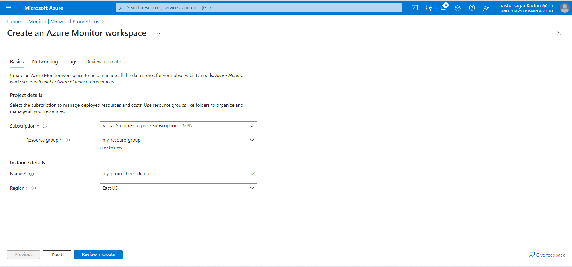

When you create an Azure Monitor workspace, a new resource group is created. The resource group name has the following format: MA_<azure-monitor-workspace-name>_<location>_managed, where the tokenized elements are lowercased. The resource group contains both a data collection endpoint and a data collection rule with the same name as the workspace. The resource group and its resources are automatically deleted when you delete the workspace.

**1.2 Create an Azure Managed Grafana instance using the Azure portal.**

1. Sign in to the [Azure portal](https://portal.azure.com/) with your Azure account.
2. In the **Search resources, services, and docs (G+/)** box, enter Azure Managed Grafana and select **Azure Managed Grafana**.

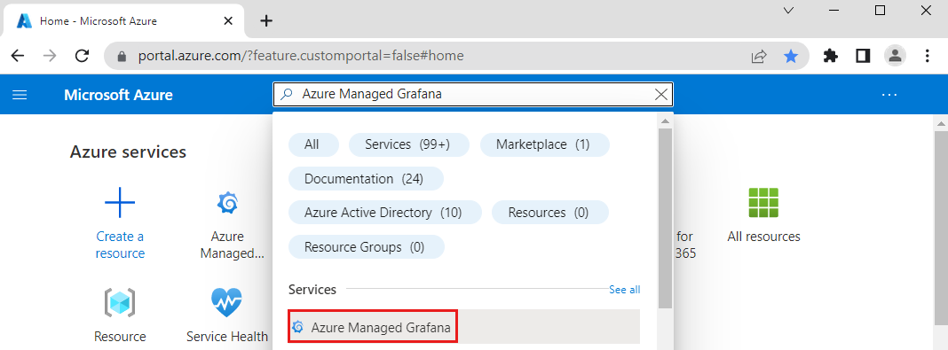

1. Select **Create**.
2. In the **Basics** pane, enter the following settings.

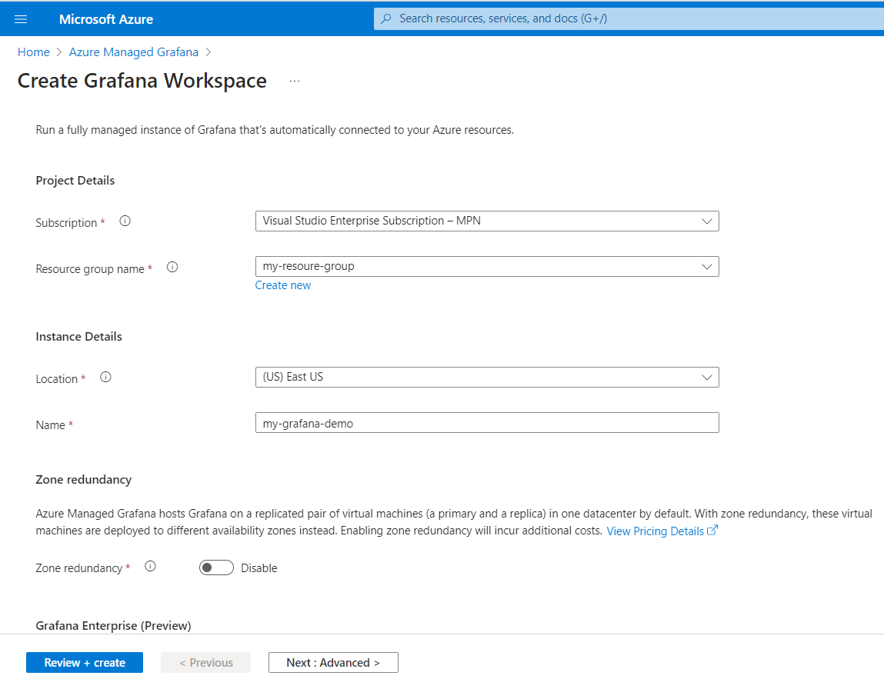

Select **Next: Advanced >** to access API key creation and statics IP address options. **Enable API key creation** and **Deterministic outbound IP** options are set to **Disable** by default. Optionally enable API key creation and enable a static IP address.

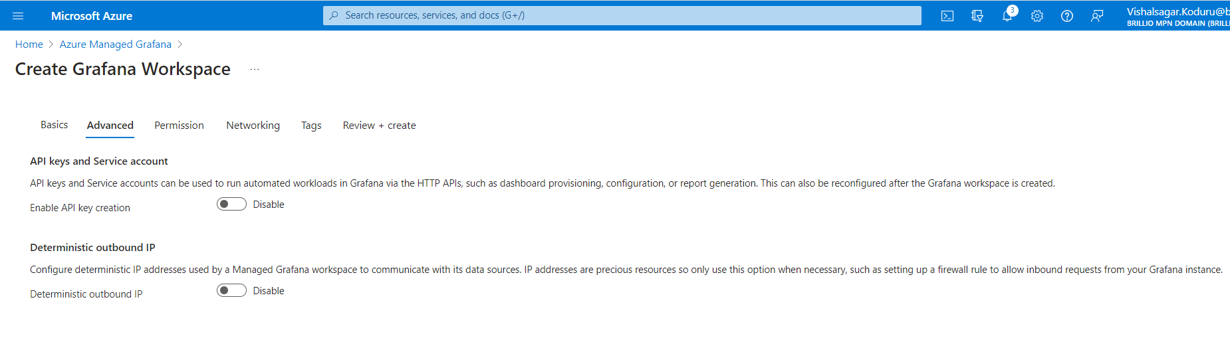

Select **Next: Permission >** to control access rights for your Grafana instance and data sources:

1. **System assigned managed identity** is set to **On**.
2. The box **Add role assignment to this identity with 'Monitoring Reader' role on target subscription** is checked by default.
3. The box **Include myself** under **Grafana administrator role** is checked. This option grants you the Grafana administrator role, and lets you manage access rights. You can give this right to more members by selecting **Add**. If this option grays out for you, ask someone with the Owner role on the subscription to assign you the Grafana Admin role.

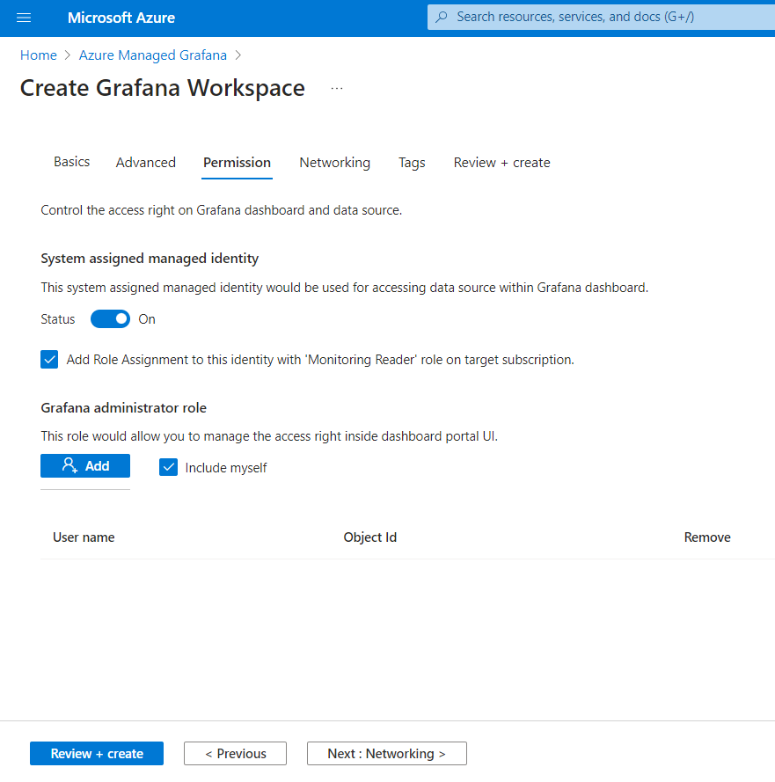

Select **Next: Review + create >**. After validation runs, select **Create**. Your Azure Managed Grafana resource is deploying.

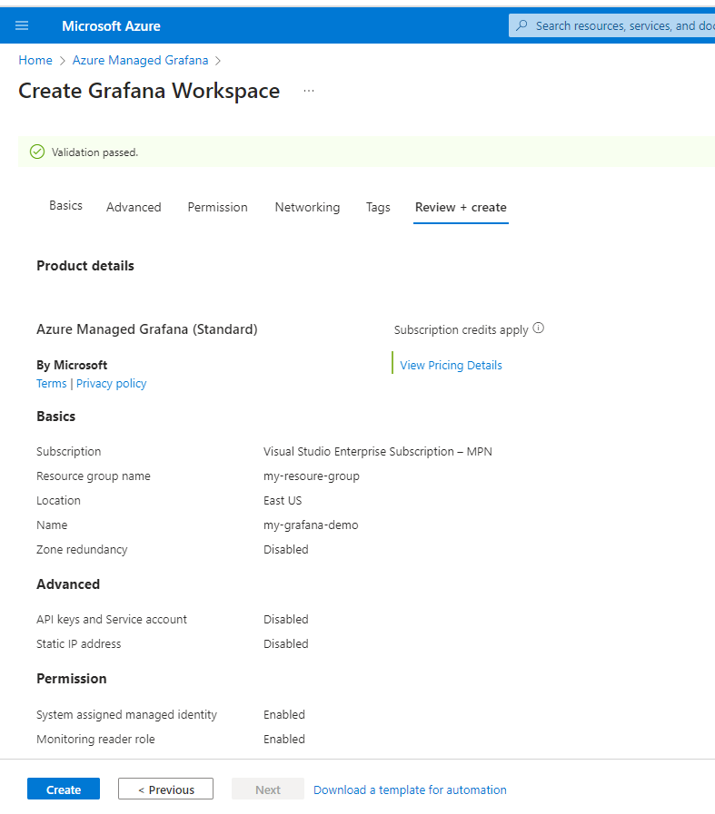

**Access your Managed Grafana instance:**

1. Once the deployment is complete, select **Go to resource** to open your resource.
2. In the **Overview** tab's Essentials section, select the **Endpoint** URL. Single sign-on via Azure Active Directory has been configured for you automatically. If prompted, enter your Azure account.

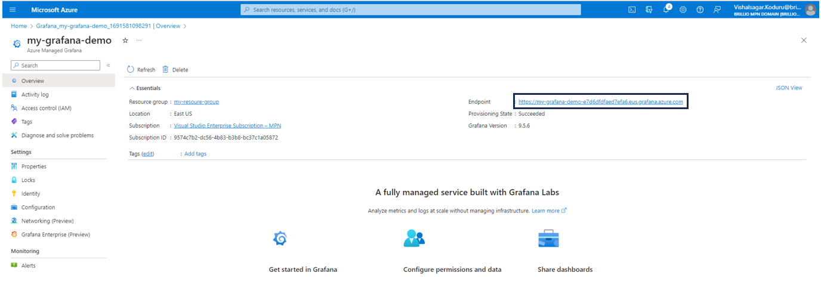

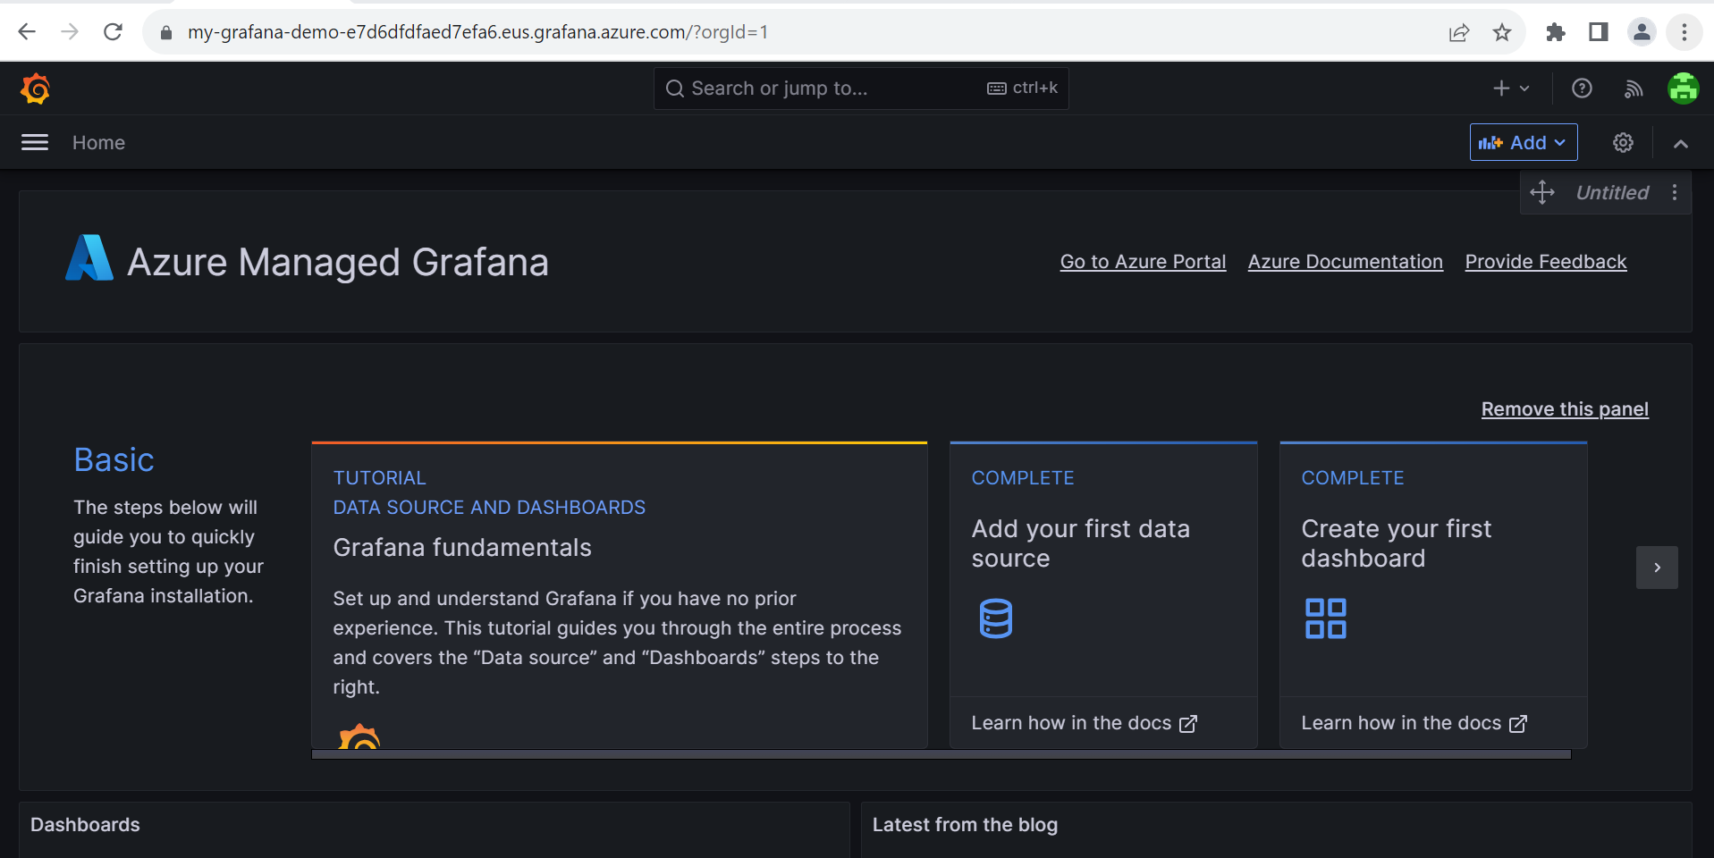

You can now start interacting with the Grafana application to configure data sources, create dashboards, reports and alerts.

**1.3 Configure managed system identity for Managed Prometheus and Azure Managed Grafana.**

The following sections describe how to configure Azure Monitor managed service for Prometheus as a data source for Azure Managed Grafana.

**Configure system identity.**

Your Grafana workspace requires the following settings:

* System managed identity enabled.
* **Monitoring Data Reader** role for the Azure Monitor workspace.

Both of these settings are configured by default when you created your Grafana workspace and linked it to an Azure Monitor workspace. Verify these settings on the **Identity** page for your Grafana workspace.

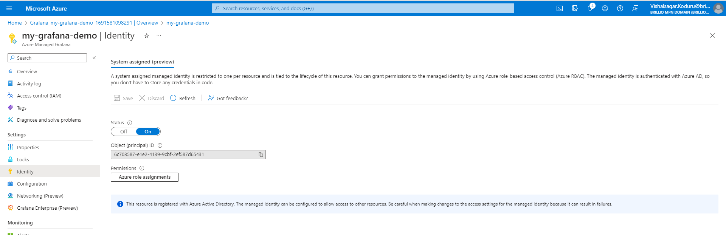

**Configure from Grafana workspace**  
Use the following steps to allow access all Azure Monitor workspaces in a resource group or subscription:

1. Open the **Identity** page for your Grafana workspace in the Azure portal.
2. If **Status** is **No**, change it to **Yes**.
3. Select **Azure role assignments** to review the existing access in your subscription.
4. If **Monitoring Data Reader** isn't listed for your subscription or resource group:
   * 1. Select **+ Add role assignment**.
     2. For **Scope**, select either **Subscription** or **Resource group**.
     3. For **Role**, select **Monitoring Data Reader**.
     4. Select **Save**.

**Configure from Azure Monitor workspace**  
Use the following steps to allow access to only a specific Azure Monitor workspace:

1. Open the **Access Control (IAM)** page for your Azure Monitor workspace in the Azure portal.

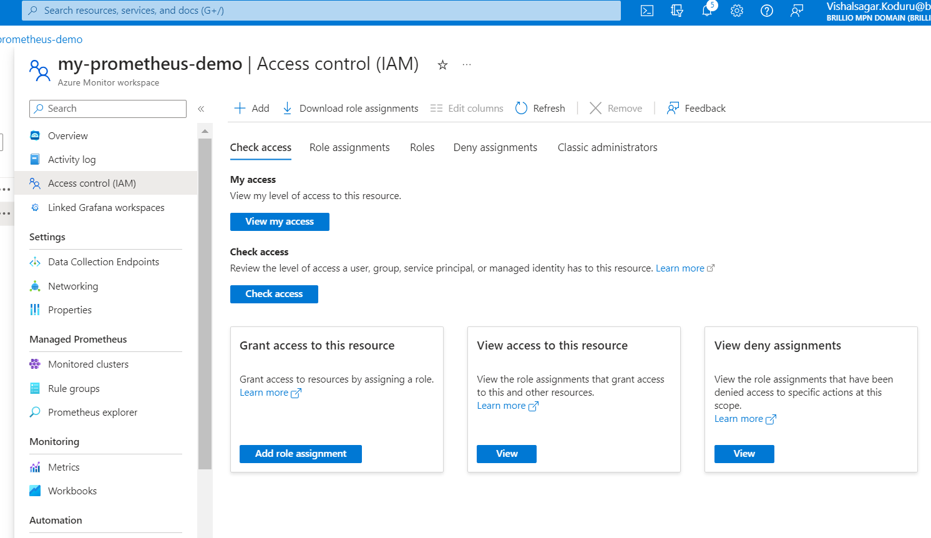

1. Select **Add role assignment**.
2. Select **Monitoring Data Reader** and select **Next**.

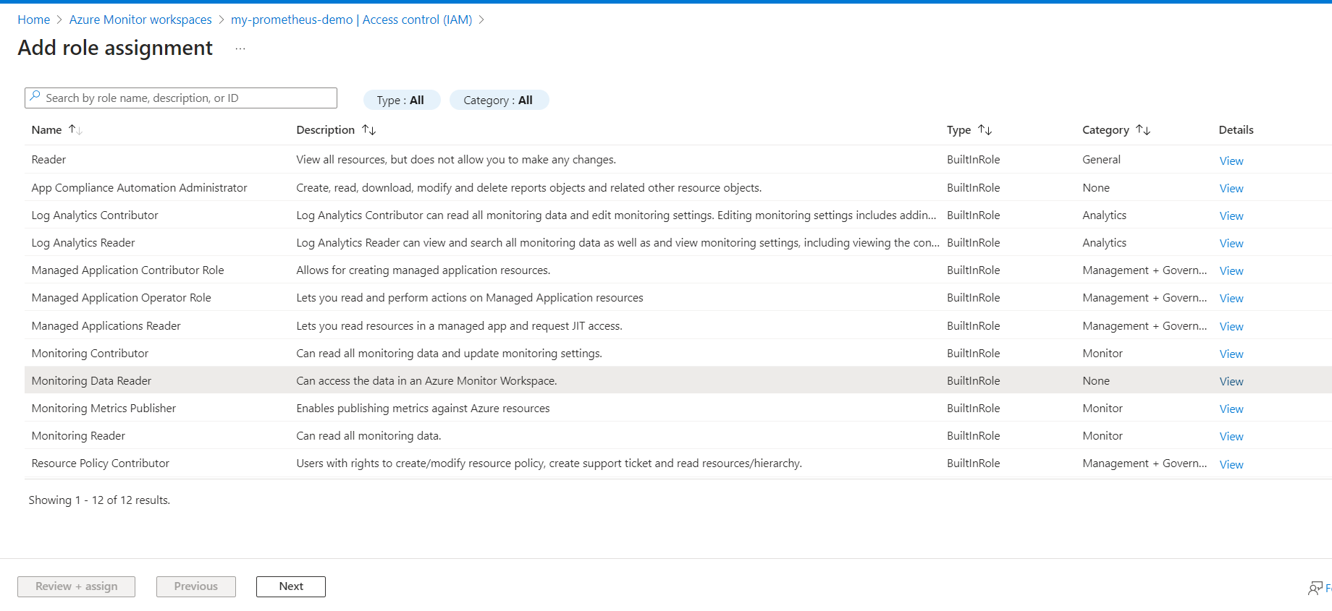

1. For **Assign access to**, select **Managed identity**.
2. Select **+ Select members**.
3. For **Managed identity**, select **Azure Managed Grafana**.
4. Select your Grafana workspace and then select **Select**.

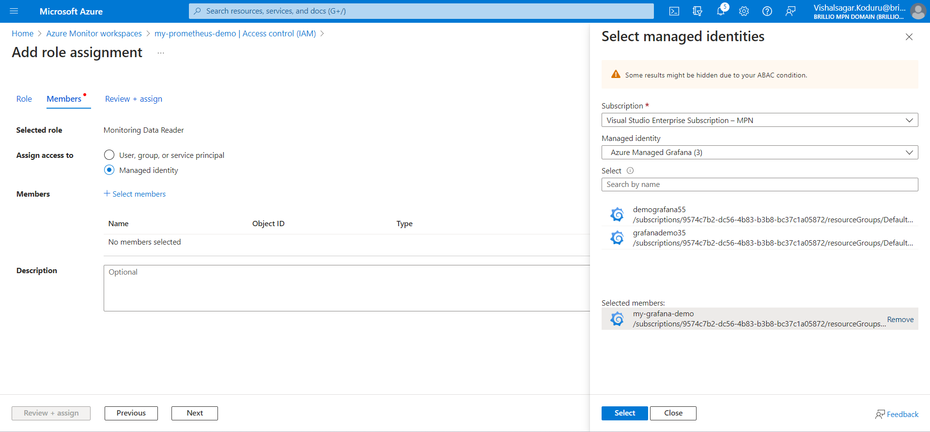

1. Select **Review + assign** to save the configuration.

**2. AKS Metrics collection**

**2.1 Create Prometheus data source in Grafana dashboard:**

Azure Managed Grafana supports Azure authentication by default.

1. Open the **Overview** page for your Azure Monitor workspace in the Azure portal.
2. Copy the **Query endpoint**, which you'll need in a step below.
3. Open your Azure Managed Grafana workspace in the Azure portal.
4. Select on the **Endpoint** to view the Grafana workspace.
5. Select **Configuration** and then **Data source**.
6. Select **Add data source** and then **Prometheus**.
7. For **URL**, paste in the query endpoint for your Azure Monitor workspace.
8. Select **Azure Authentication** to turn it on.
9. For **Authentication** under **Azure Authentication**, select **Managed Identity**.
10. Scroll to the bottom of the page and select **Save & test**.

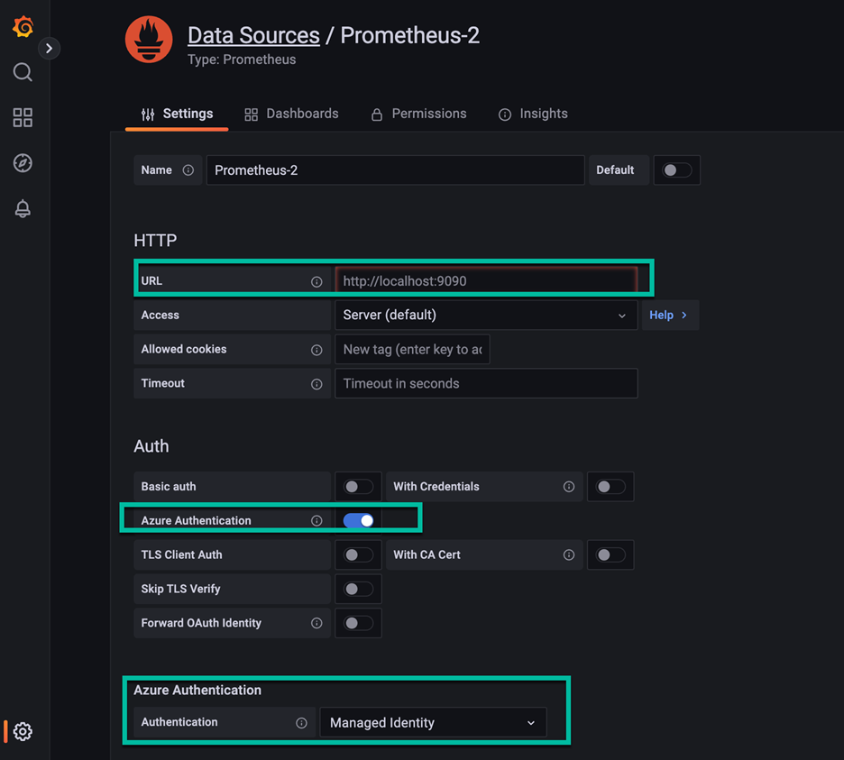

**2.2 Collect Prometheus metrics from an AKS cluster.**

Now let’s see, how to configure your Azure Kubernetes Service (AKS) cluster to send data to Azure Monitor managed service for Prometheus. When you perform this configuration, a containerized version of the [Azure Monitor agent](https://learn.microsoft.com/en-us/azure/azure-monitor/agents/agents-overview) is installed with a metrics extension. This sends data to the Azure Monitor workspace that you specify.

**Enable Prometheus metric collection.**

Use any of the following methods to install the Azure Monitor agent on your AKS cluster and send Prometheus metrics to your Azure Monitor workspace.

There are multiple options to enable Prometheus metrics on your cluster from the Azure portal.

**New cluster**

When you create a new AKS cluster in the Azure portal, you can enable Prometheus, Container insights, and Grafana from the **Integrations** tab.

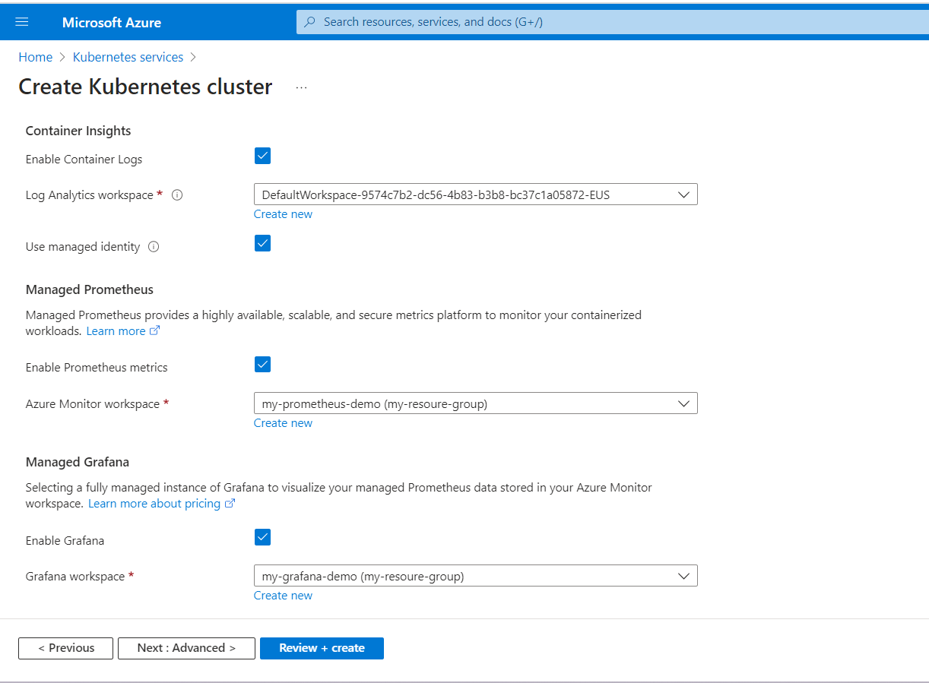

#### **From the Azure Monitor workspace**

This option enables Prometheus metrics on a cluster without enabling Container insights.

1. Open the **Azure Monitor workspaces** menu in the Azure portal and select your workspace.
2. Select **Monitored clusters** in the **Managed Prometheus** section to display a list of AKS clusters.
3. Select **Configure** next to the cluster you want to enable.

#### **From an existing cluster**

This option enables Prometheus, Grafana, and Container insights on a cluster.

1. Open the clusters menu in the Azure portal and select **Insights**.
2. Select **Configure monitoring**.
3. Container insights is already enabled. Select the checkboxes for **Enable Prometheus metrics** and **Enable Grafana**. If you have existing Azure Monitor workspace and Garafana workspace, then they're selected for you. Click **Advanced settings** to select alternate workspaces or create new ones.

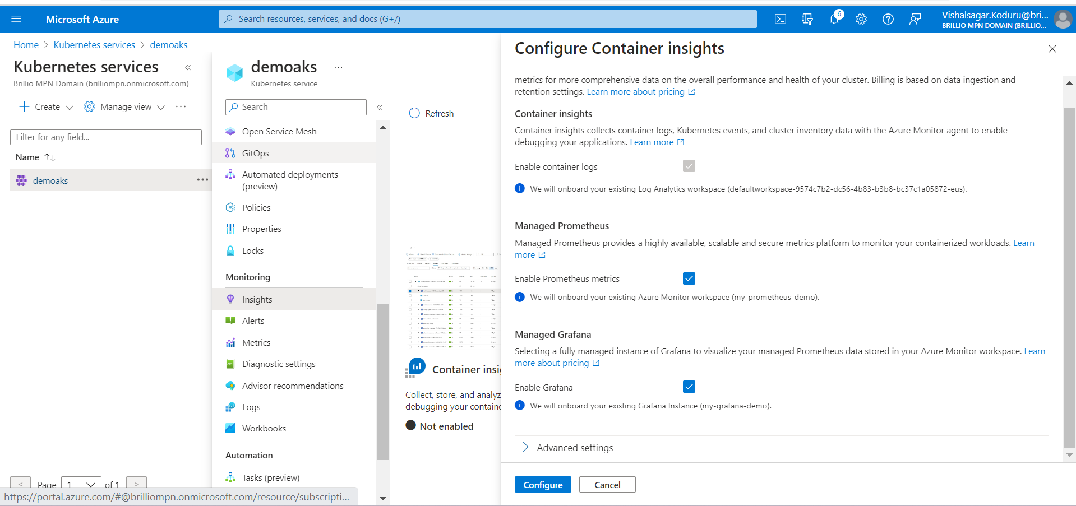

1. Click **Configure** to save the configuration.

# **2.3 Monitor your Azure Kubernetes services in Grafana.**

For accessing the Grafana dashboard click on the Endpoint URL of managed Grafana resource, now you can see a Single sign-on via Azure Active Directory has been configured for you automatically. If prompted, enter your Azure account.



Azure Monitor also supports out-of-the-box dashboards for seamless integration with Azure Monitor managed service for Prometheus. These dashboards are automatically deployed to Azure Managed Grafana when linked to Azure Monitor managed service for Prometheus.

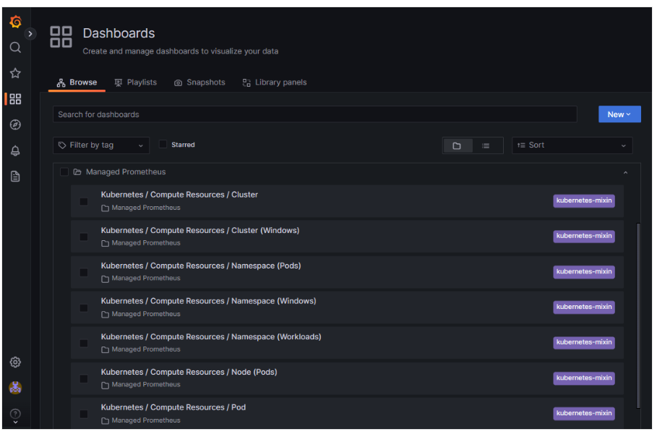

**3. Application Monitoring and Alerting.**

* 1. **Deploying the web application routing sample application.**
* Creating the Kubernetes Cluster in the Azure portal:

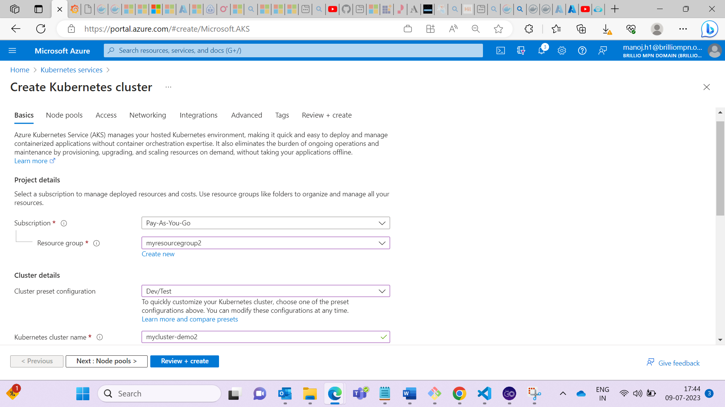

* Enabling the Prometheus and Grafana in cluster Integration blade at the time of creation of cluster:

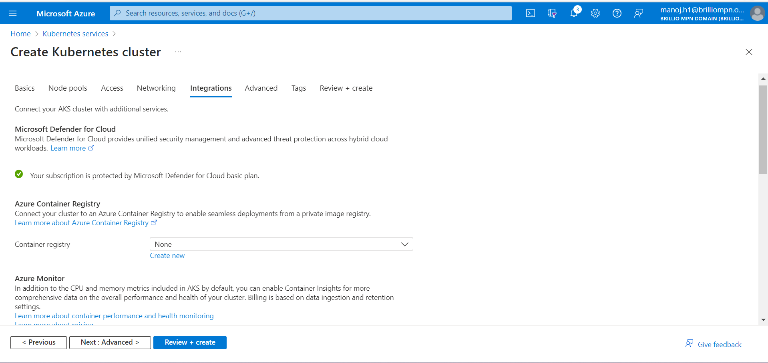

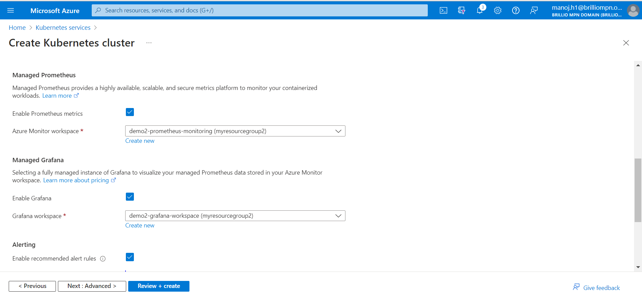

* + - The below cluster has been created successfully with Grafana and Prometheus enabled.

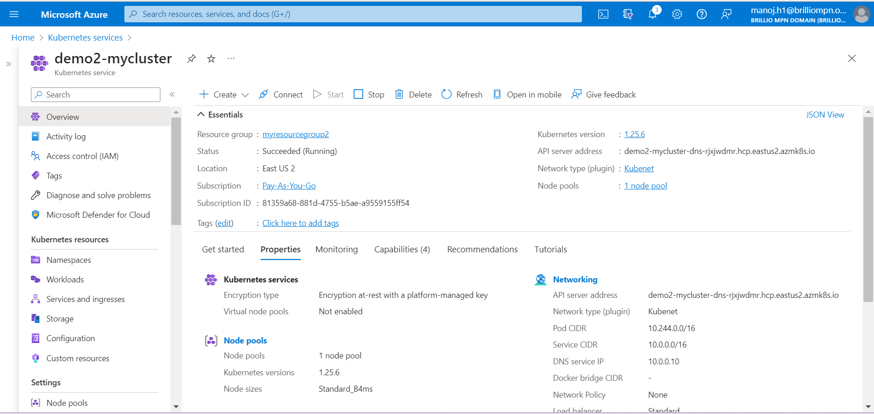

* Sample application has been deployed with in the cluster with enabled web application routing and OSM.

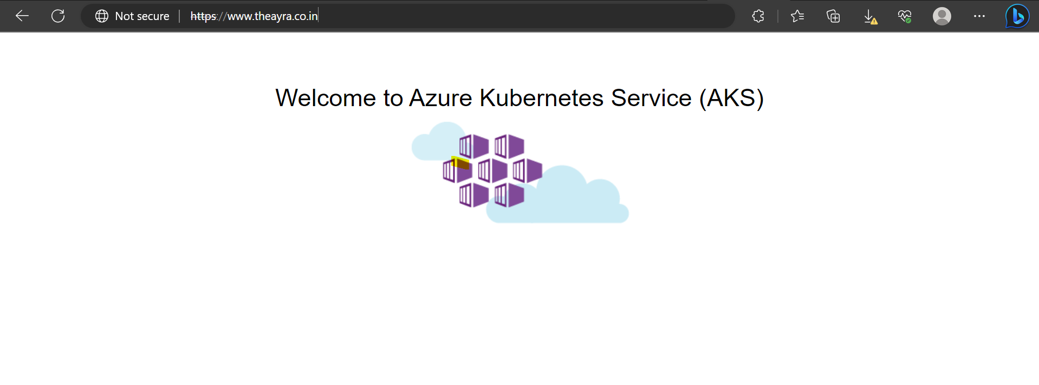

* In the Kubernetes Cluster dashboard click on > Insights >Configure monitoring

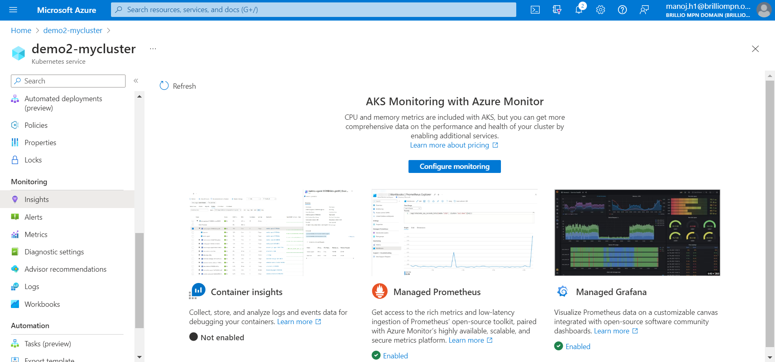

* Click on browse dashboard to access the Grafana endpoint:



**3.2 Visualizing the Prometheus Dashboard in Grafana.**

* Grafana dashboard: -
* Click on Browse

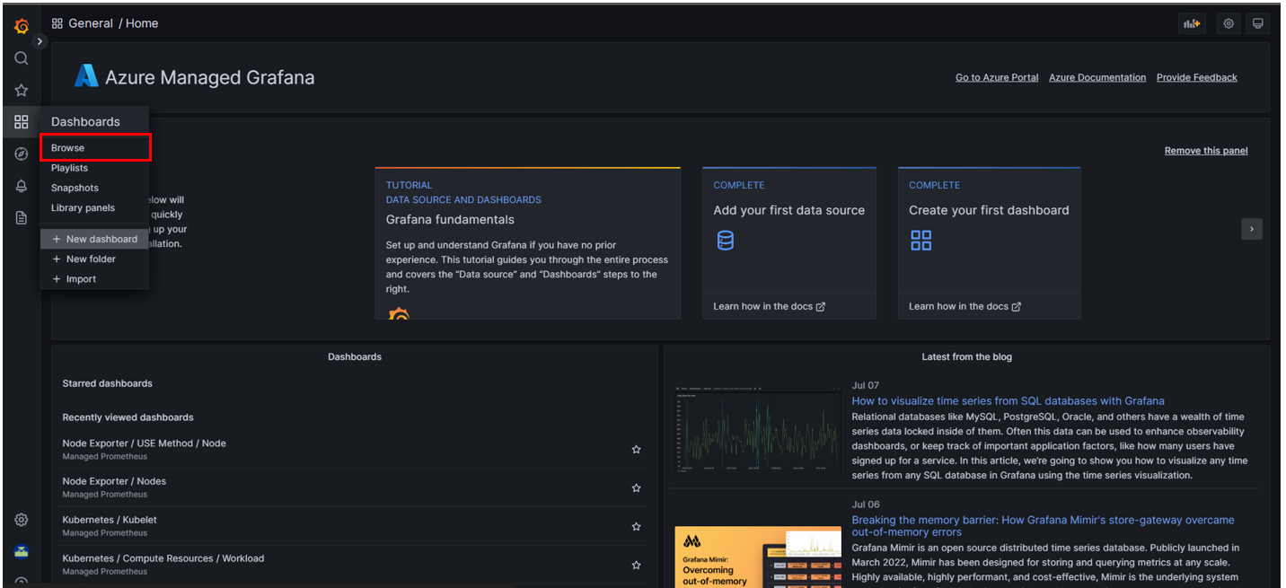

* The below are the different types of metrics dashboards for cluster, Namespaces, Pods, Nodes, and workloads.

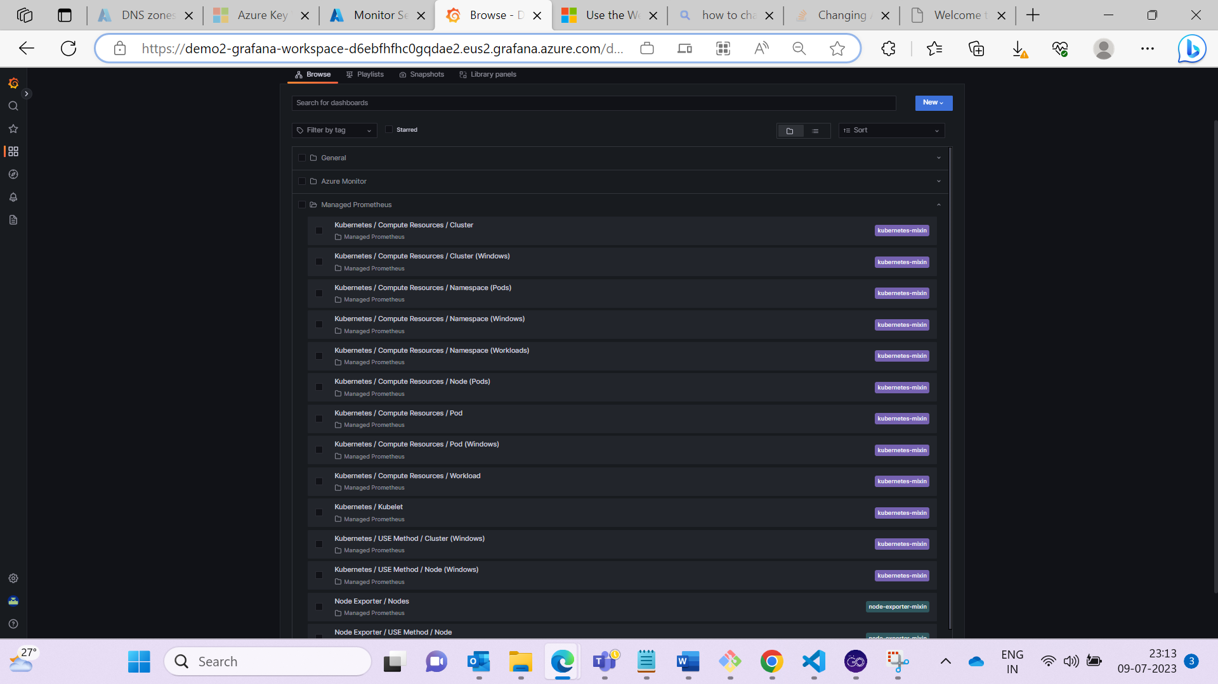

Kubernetes / Compute Resources / cluster

* If you want to view the cluster related metrics dashboard, click the below highlight. It will display all the default available metrics as shown below:

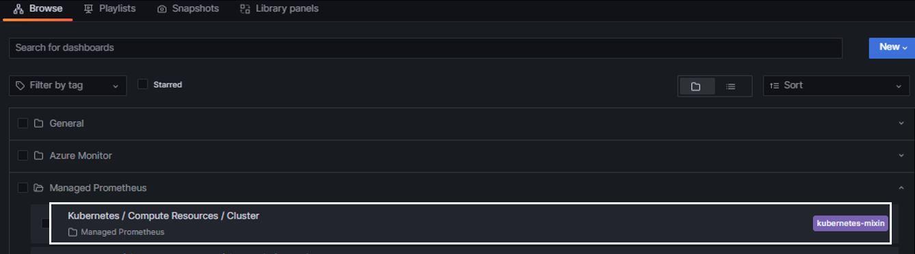

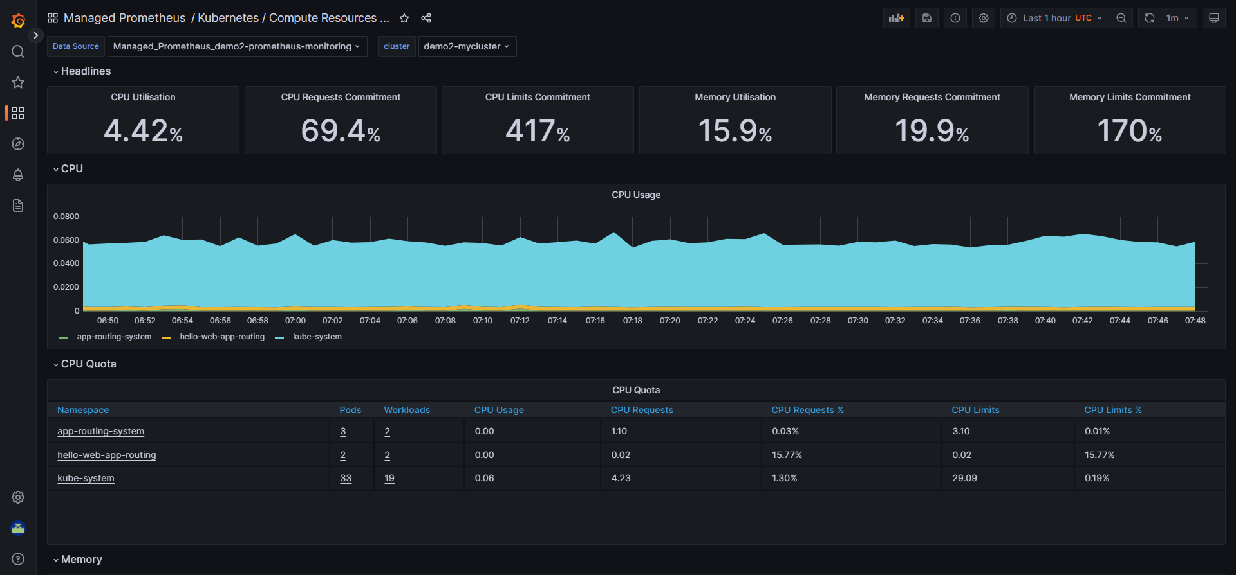

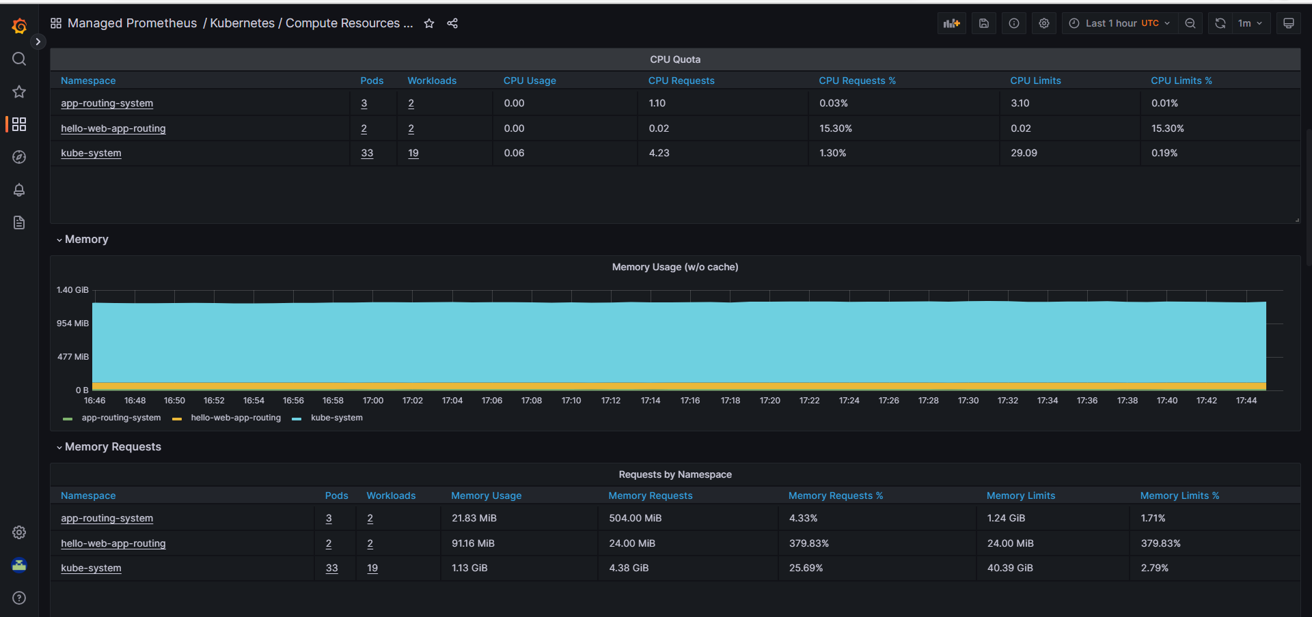

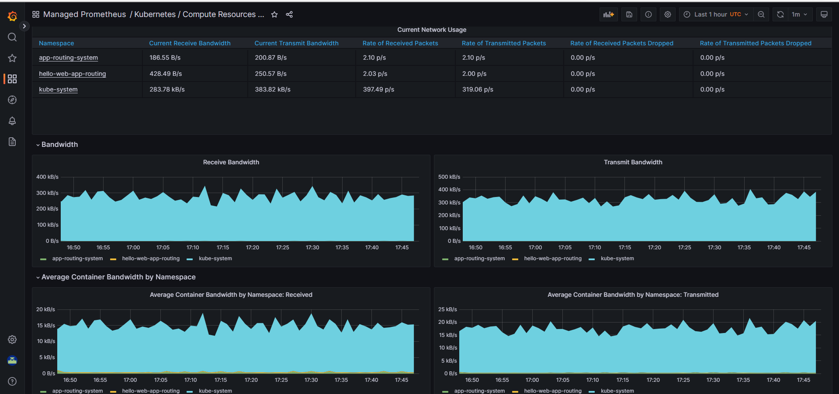

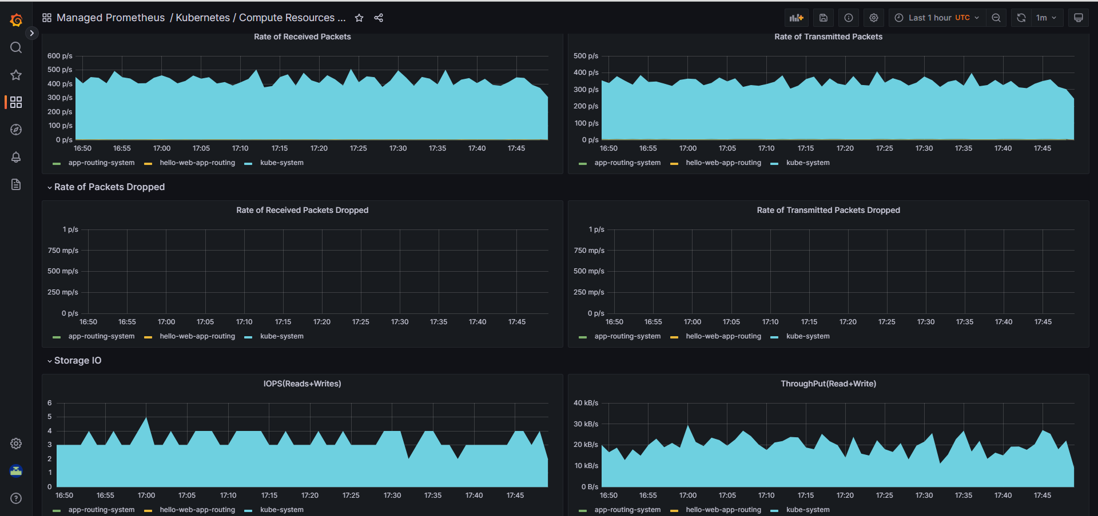

Kubernetes/Compute resources / Namespace (pods):

* If you want to view the namespace(pods) related metrics dashboard, click the below highlight.
* It will display all the default available metrics as shown below:

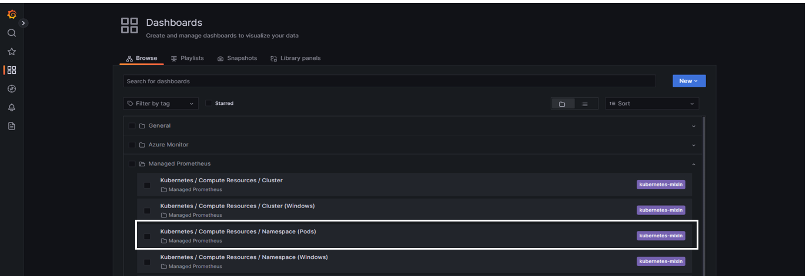

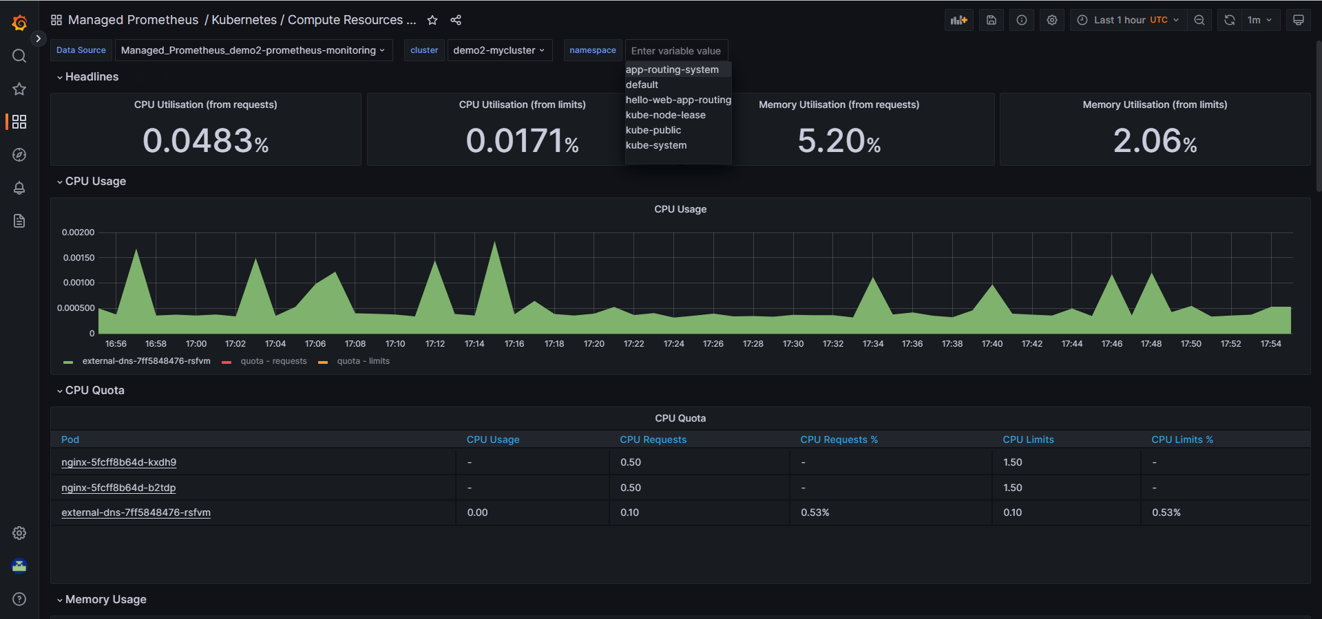

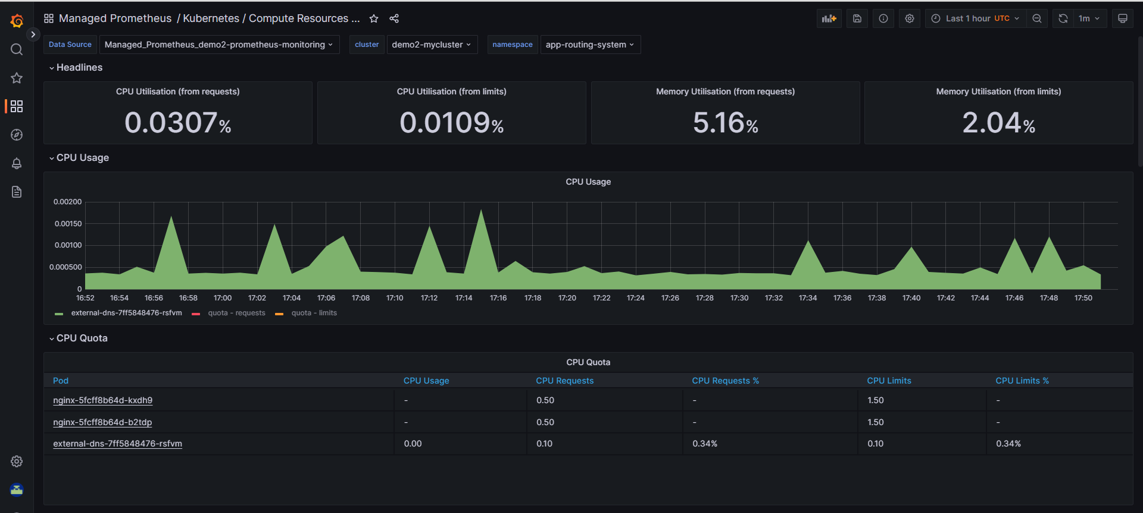

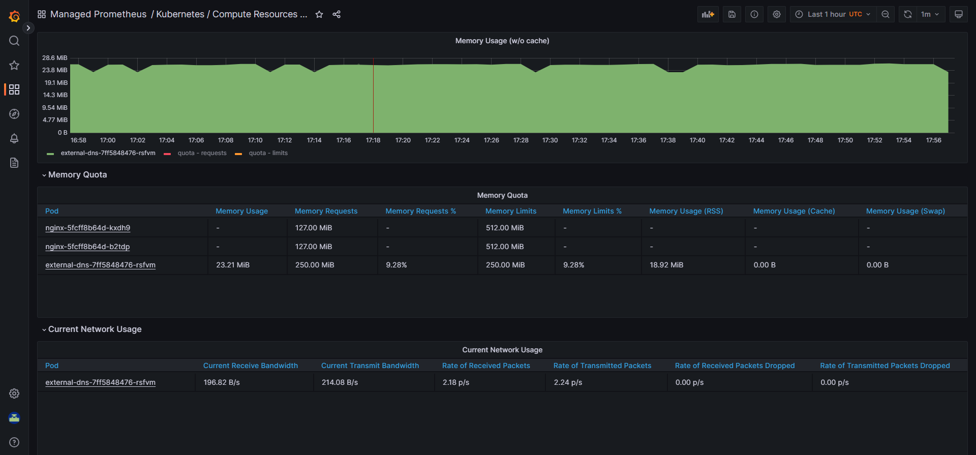



Kubernetes /Compute Resources/ Namespace (Workloads)

* If you want to view the namespace(workloads) related metrics dashboard, click the below highlight.
* It will display all the default available metrics as shown below:

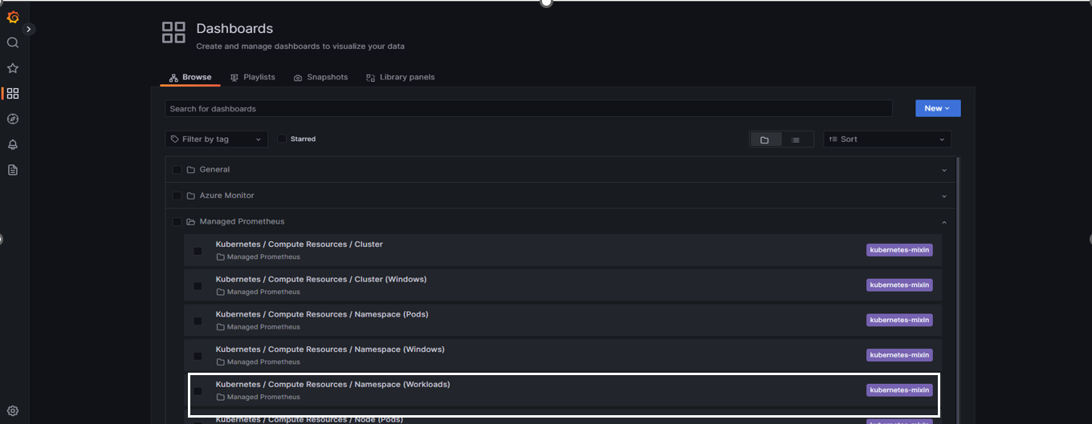

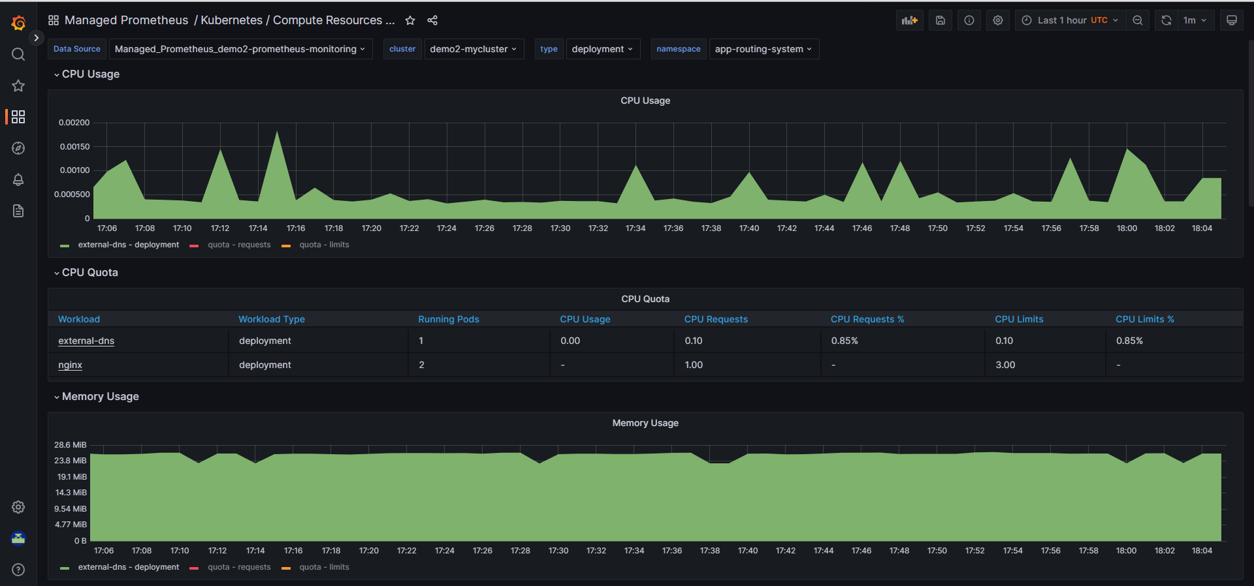

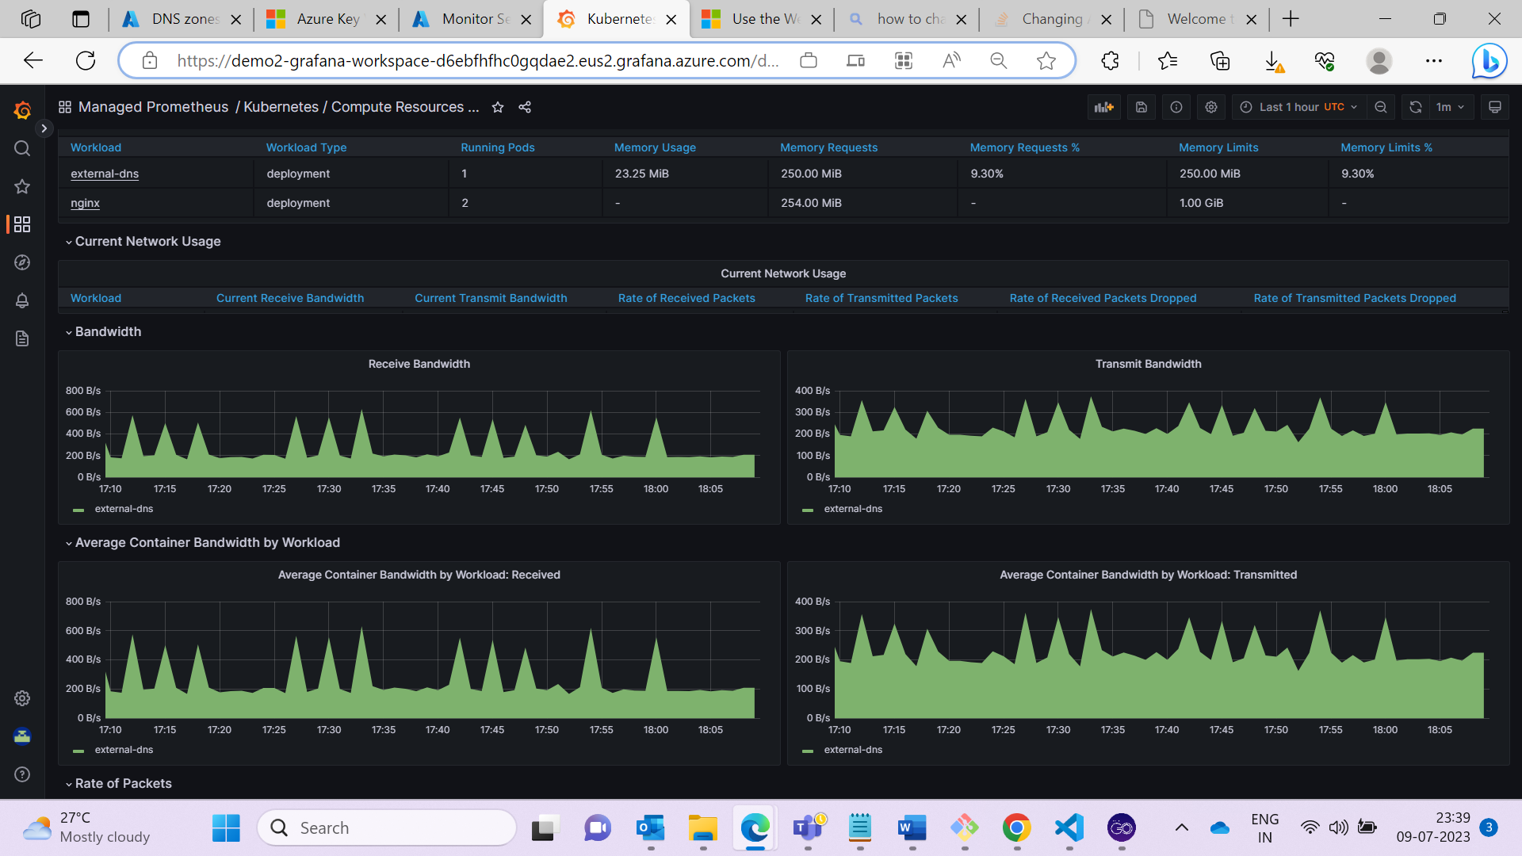

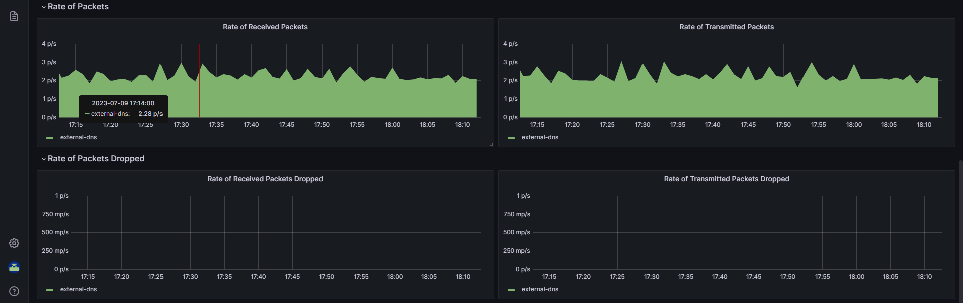

Kubernetes /Compute Resources/ Node (pods)

* If you want to view the Node(pods) related metrics dashboard, click the below highlight.
* It will display all the default available metrics as shown below:

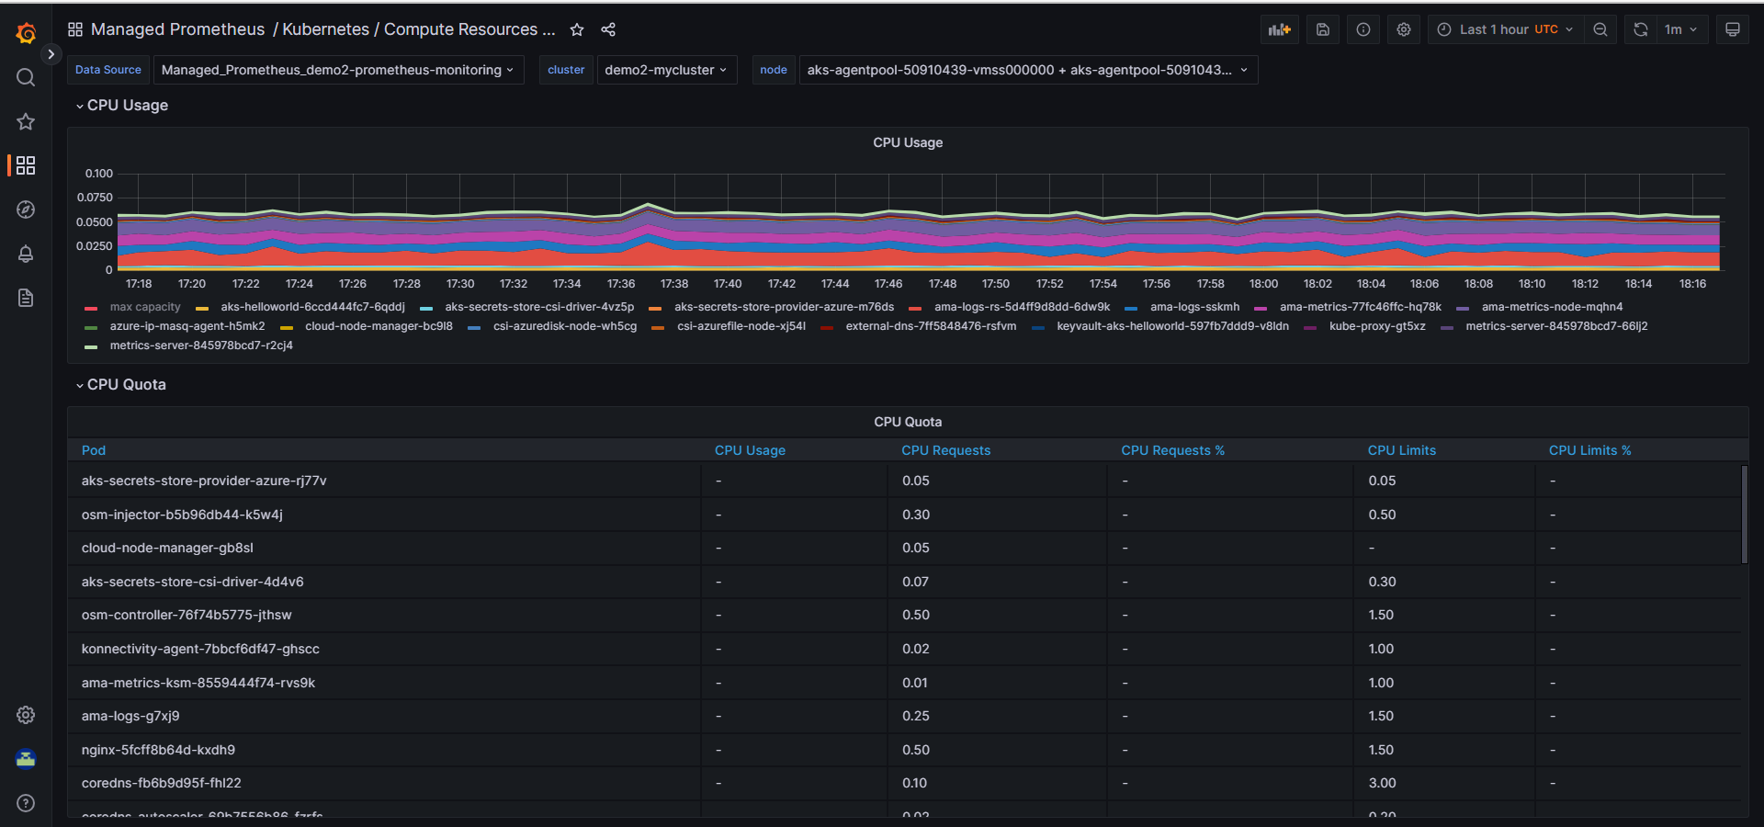

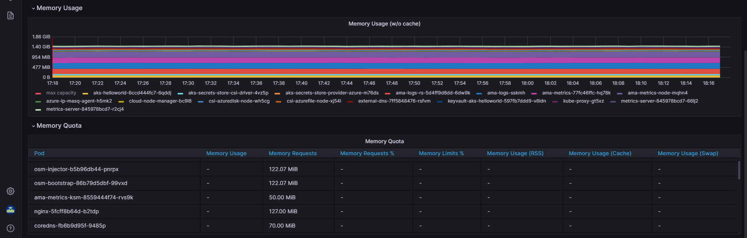

* Kubernetes /Compute Resources/Kubelet

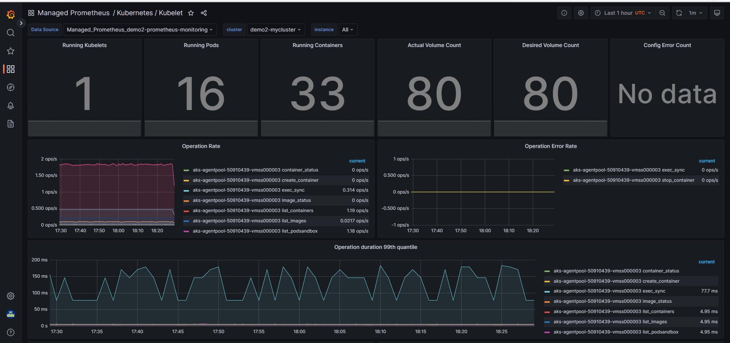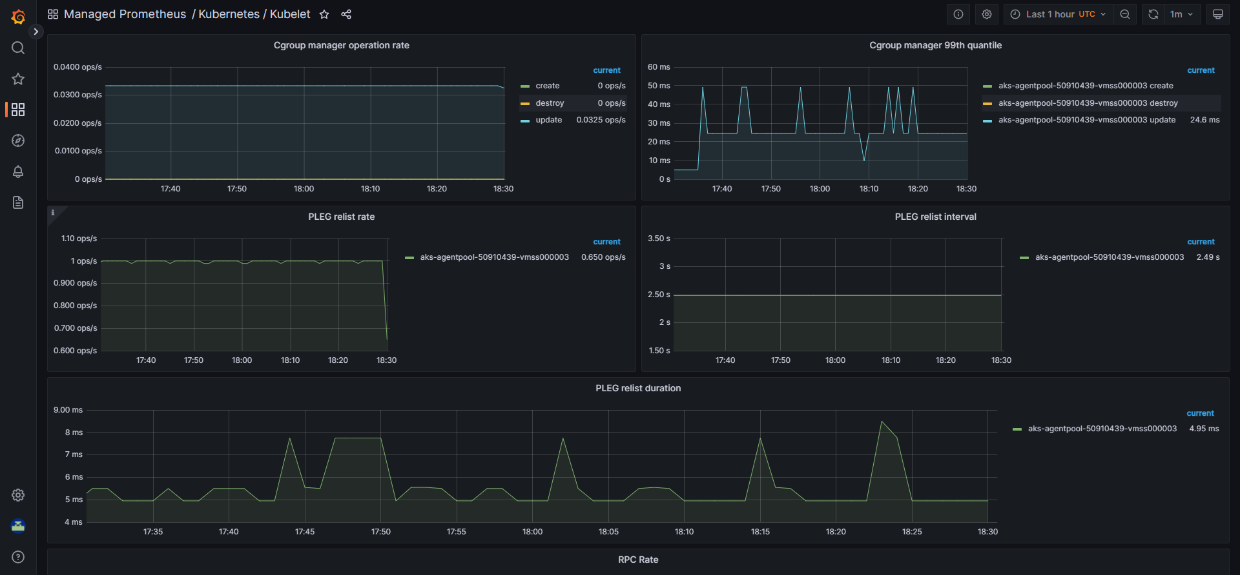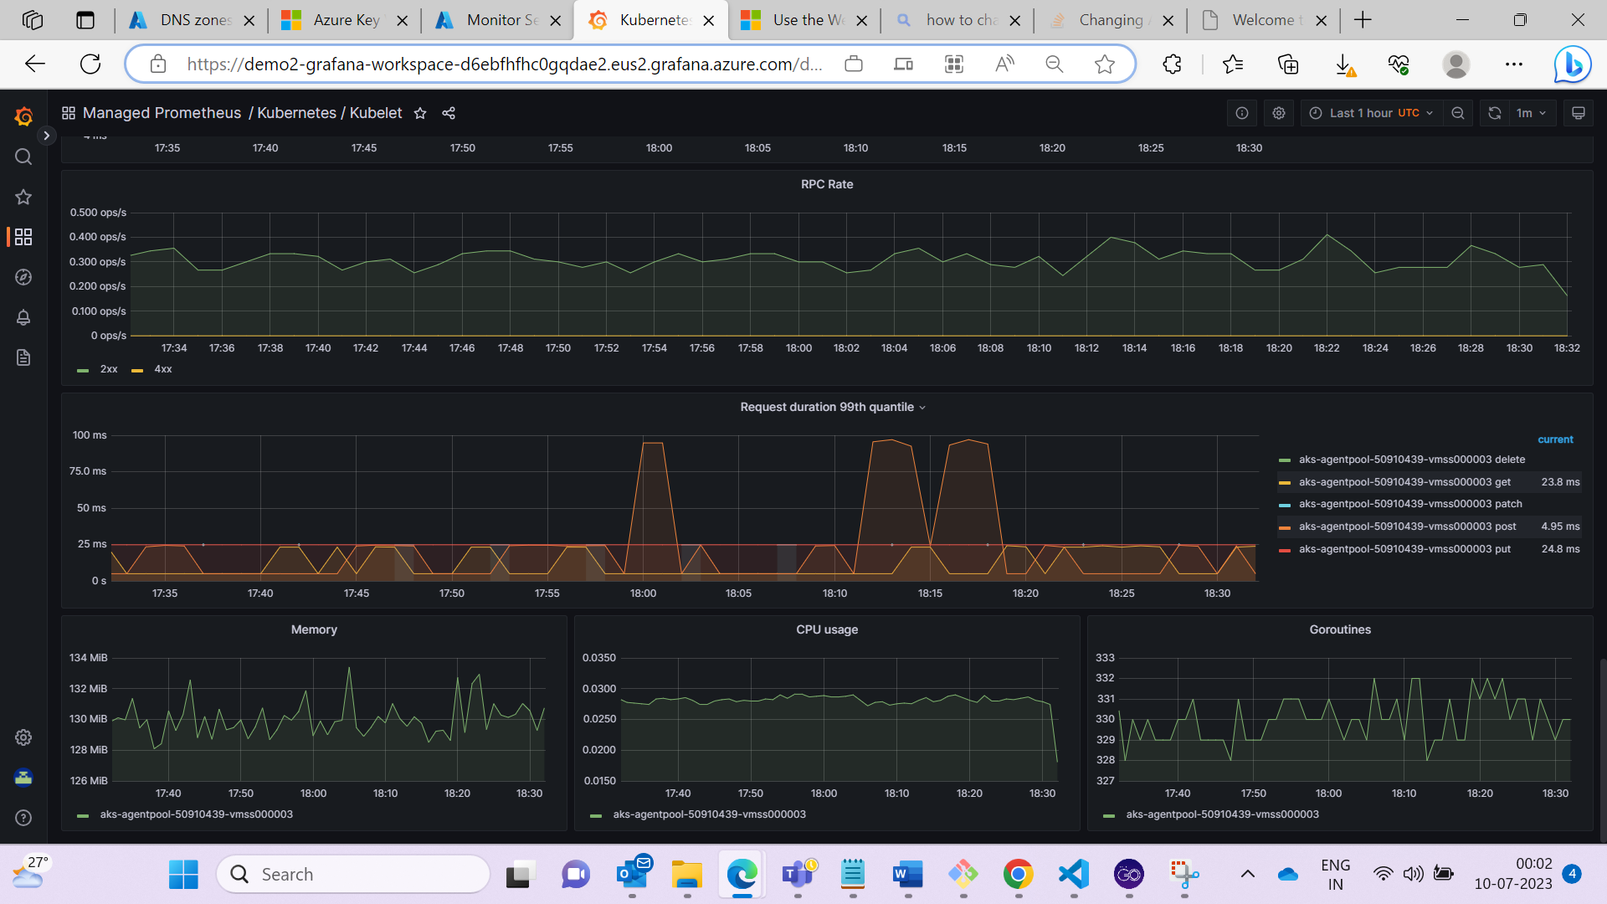

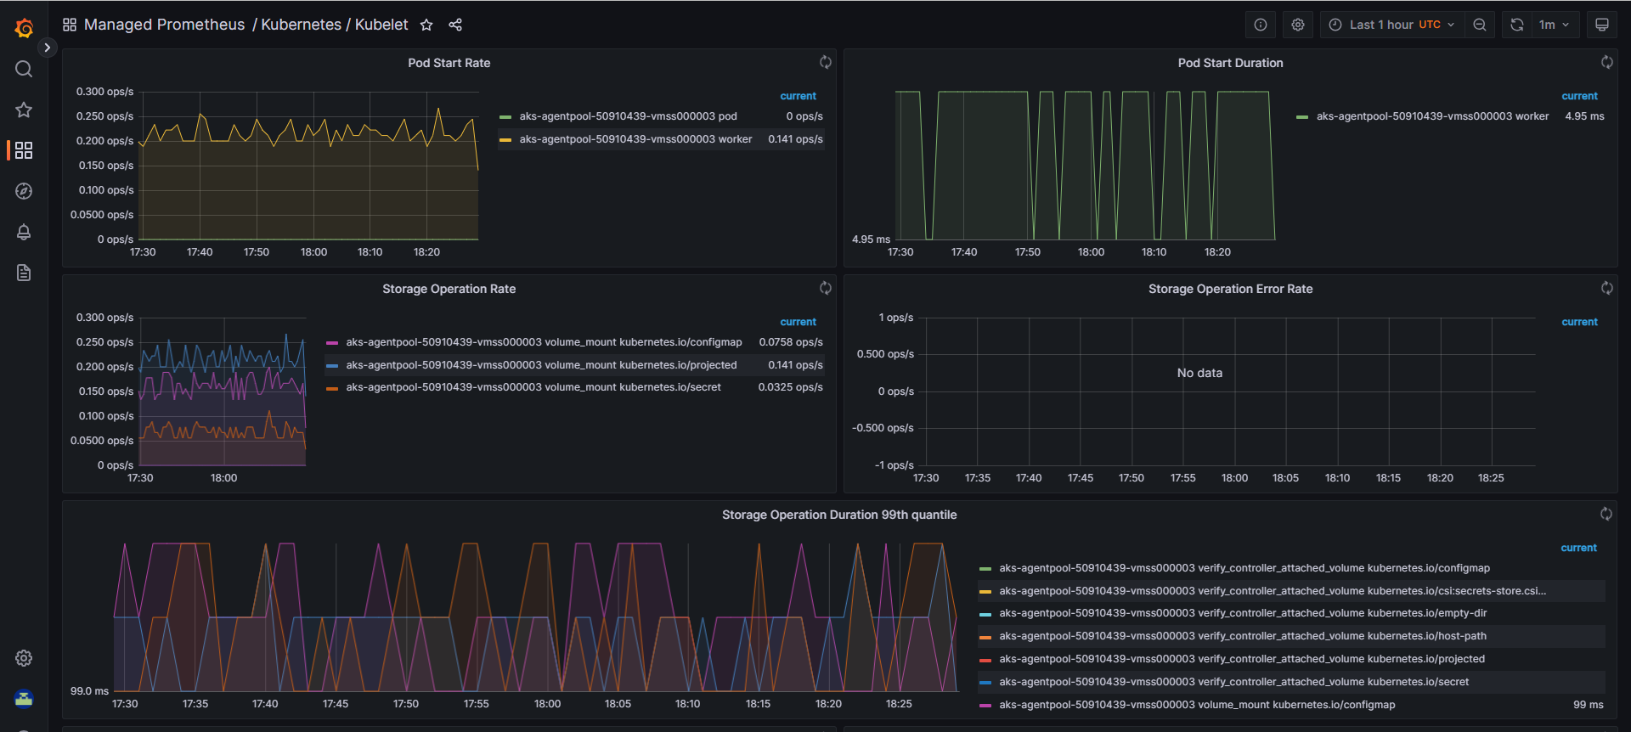

**3.3 Create the Grafana custom dashboard:**

* Go to the Grafana home page and select **New Dashboard**.

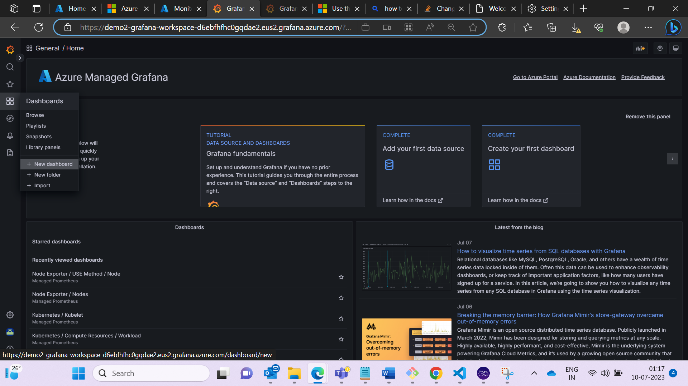

* + - Select Add panel > Add a new panel

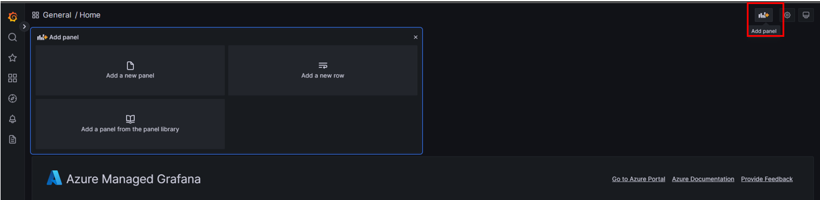

* In the data source section select Managed Prometheus as your data source.
* In the Query section we can browse different metrics other than the default one and after selection of the required metrics click on run queries.

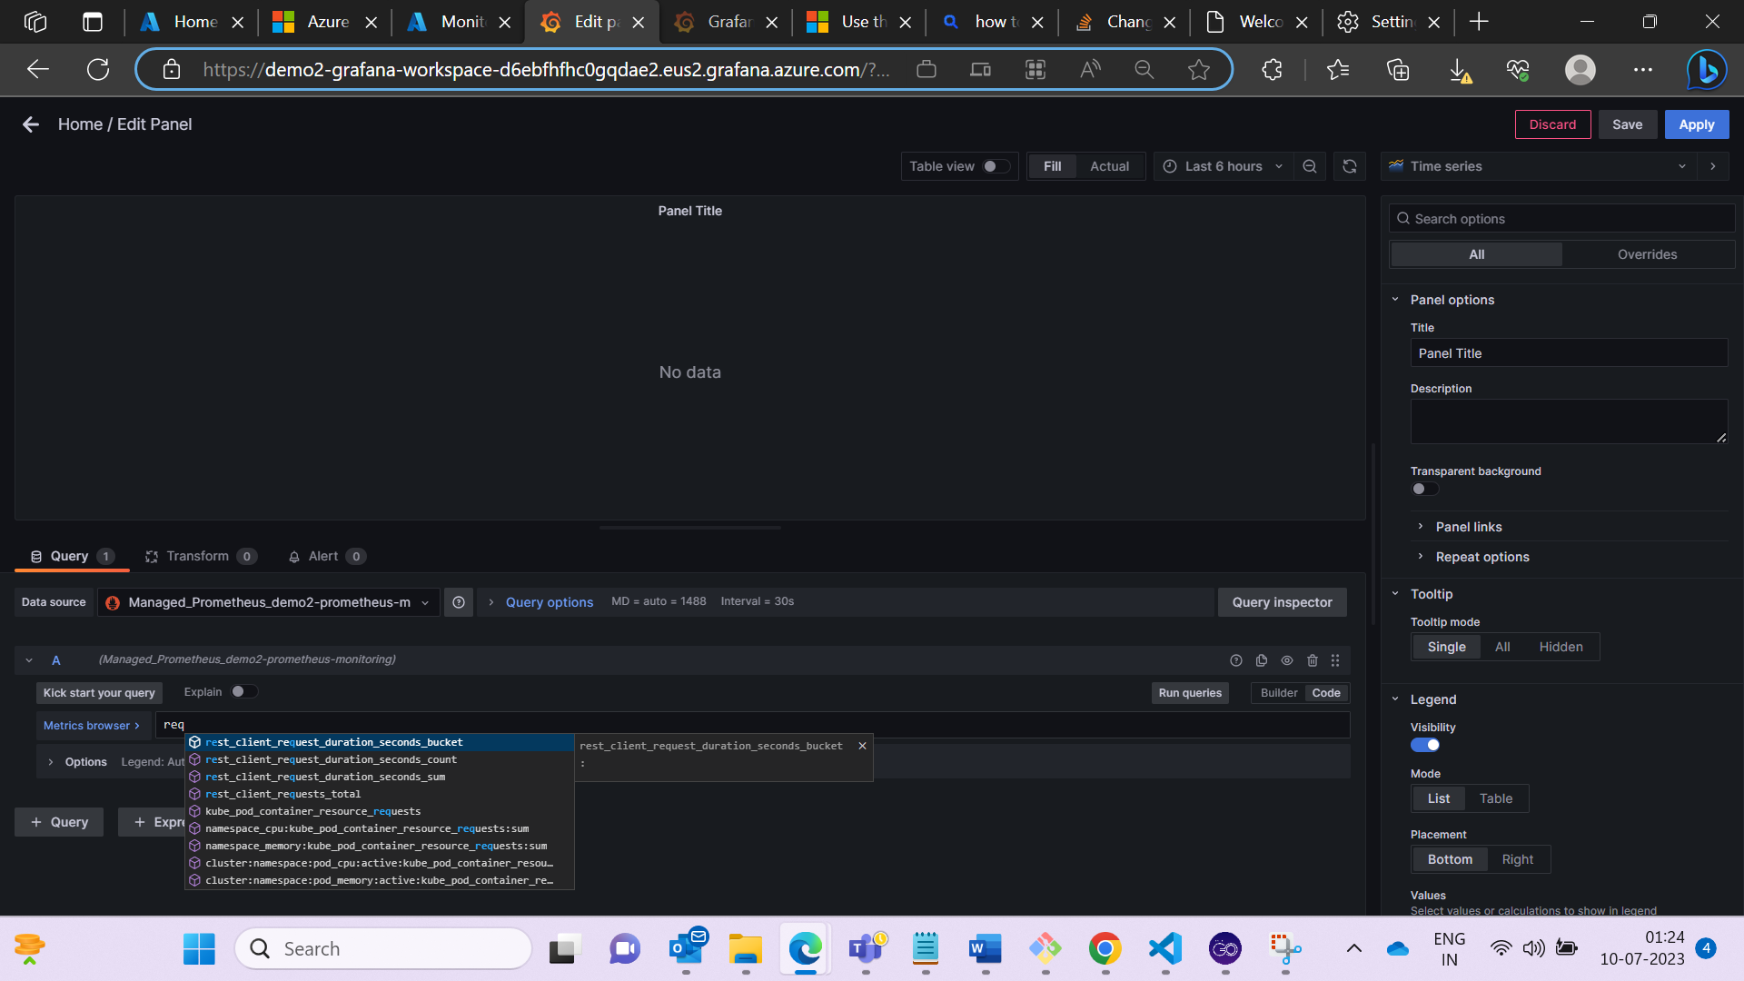

* The Metrics can be seen below.

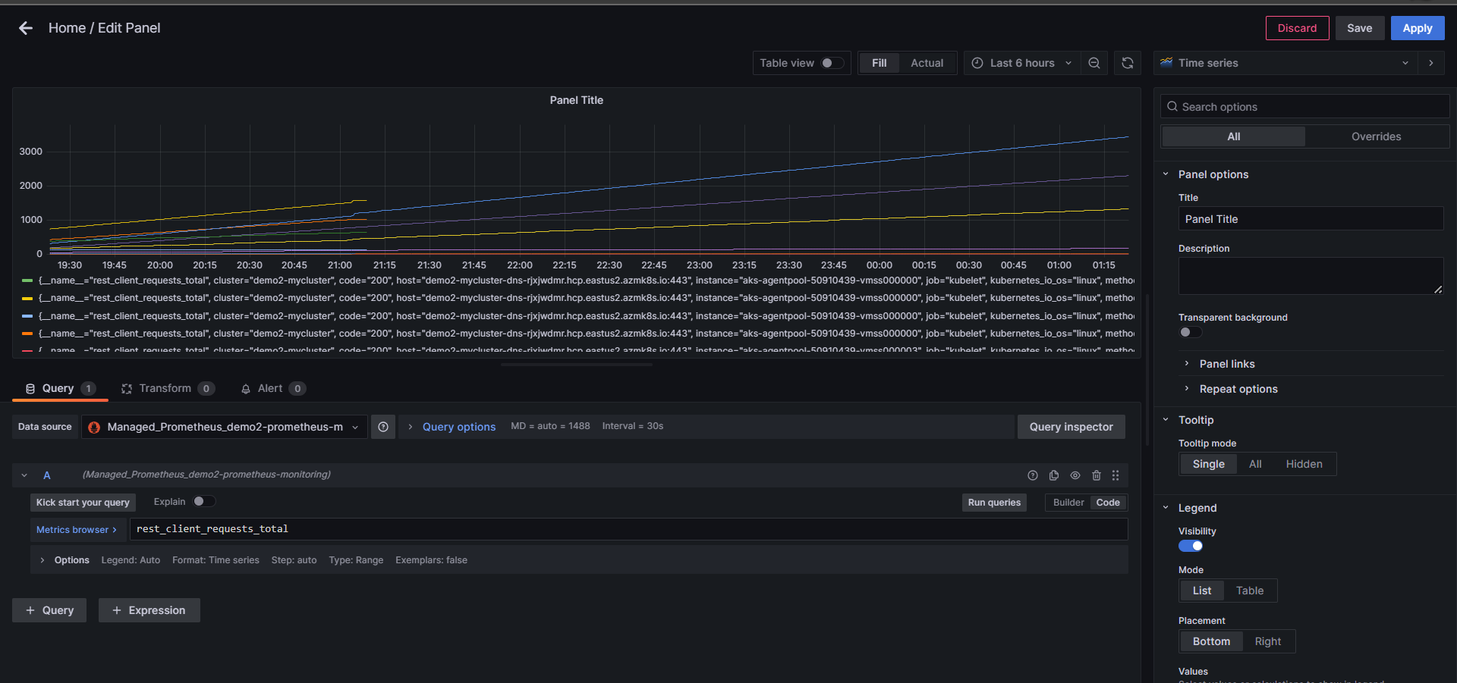

* Click on save option to save the dashboard.

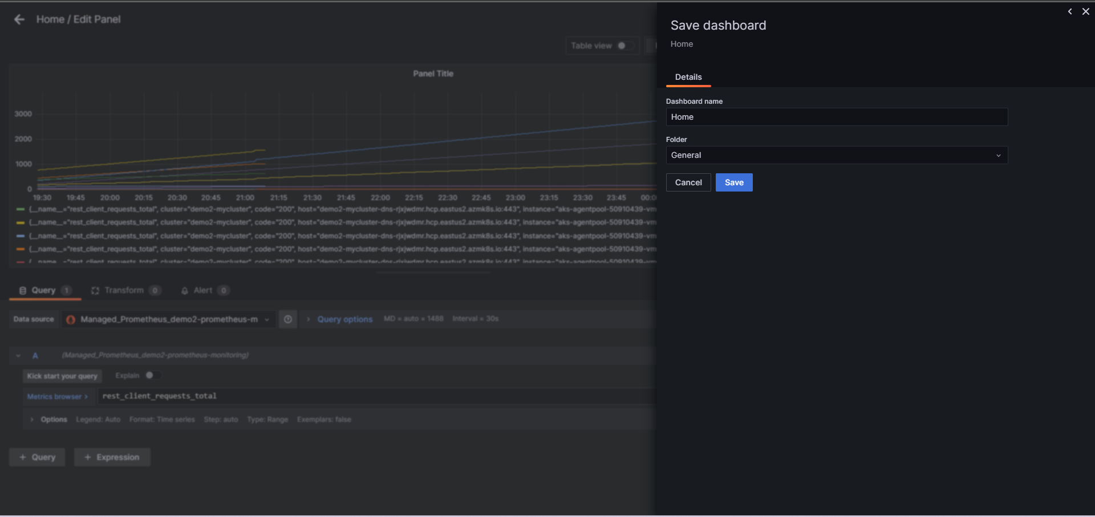

* Similarly, you can fetch metrics for different PromQL queries as shown below.

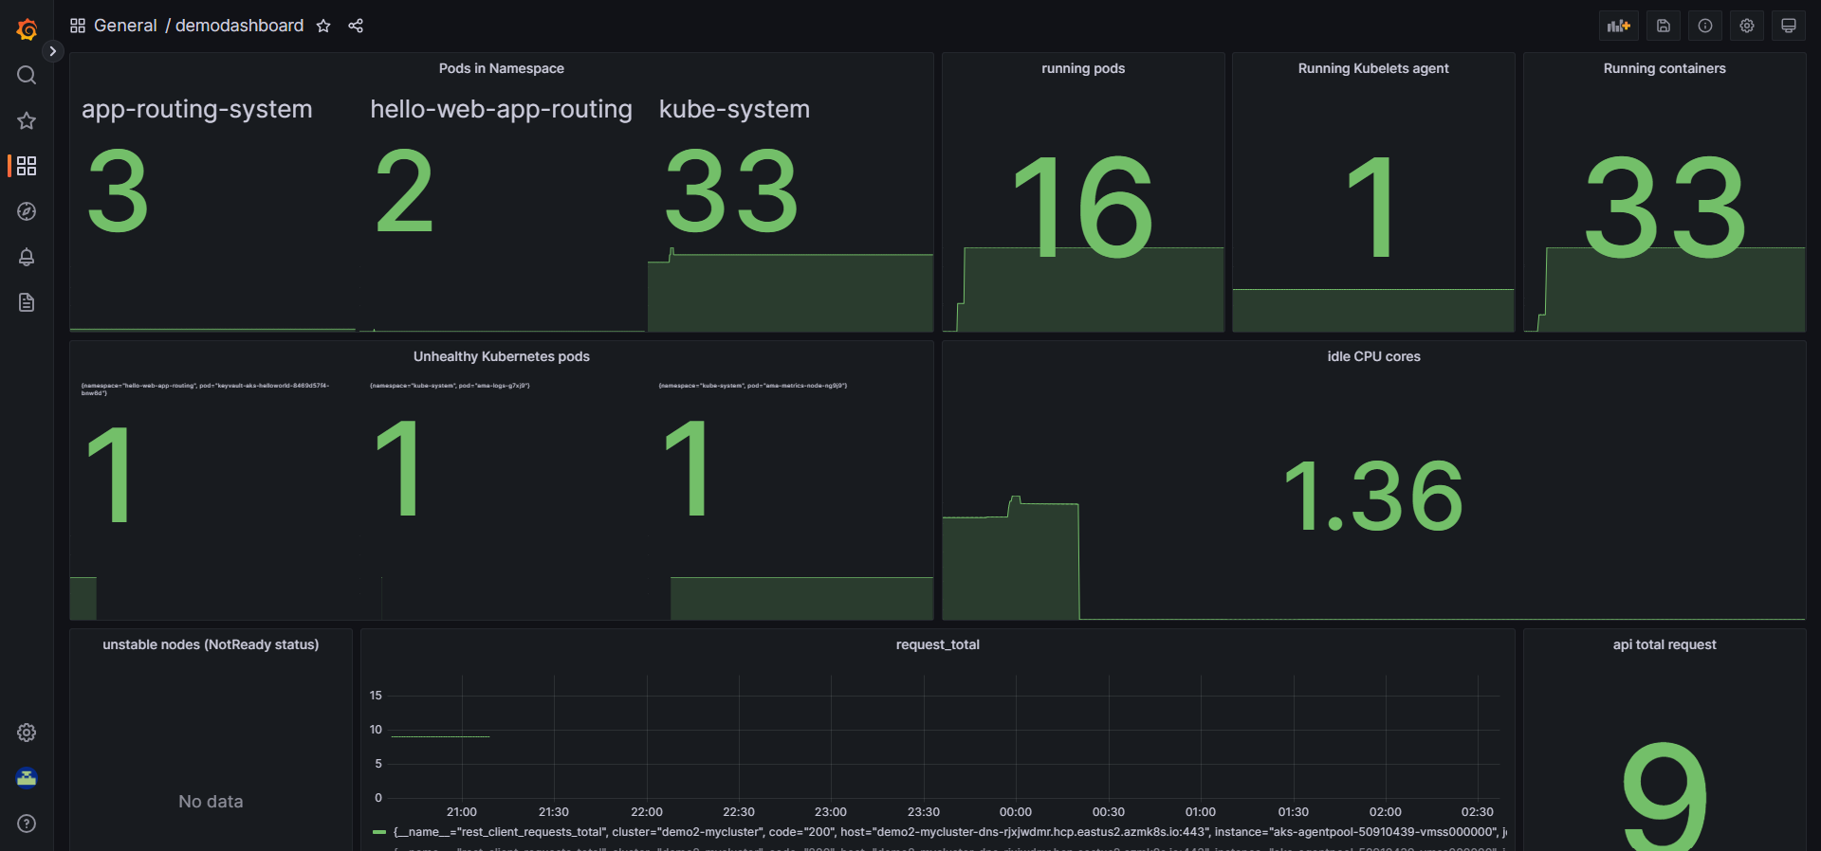

**3.4 Replicate the dashboard across clusters.**

* If we want to Export the dashboard to the other Grafana Workspace or clusters
* Click on the share option > export > save the file.

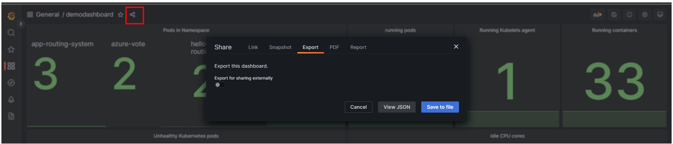

* Importing the Dashboard:

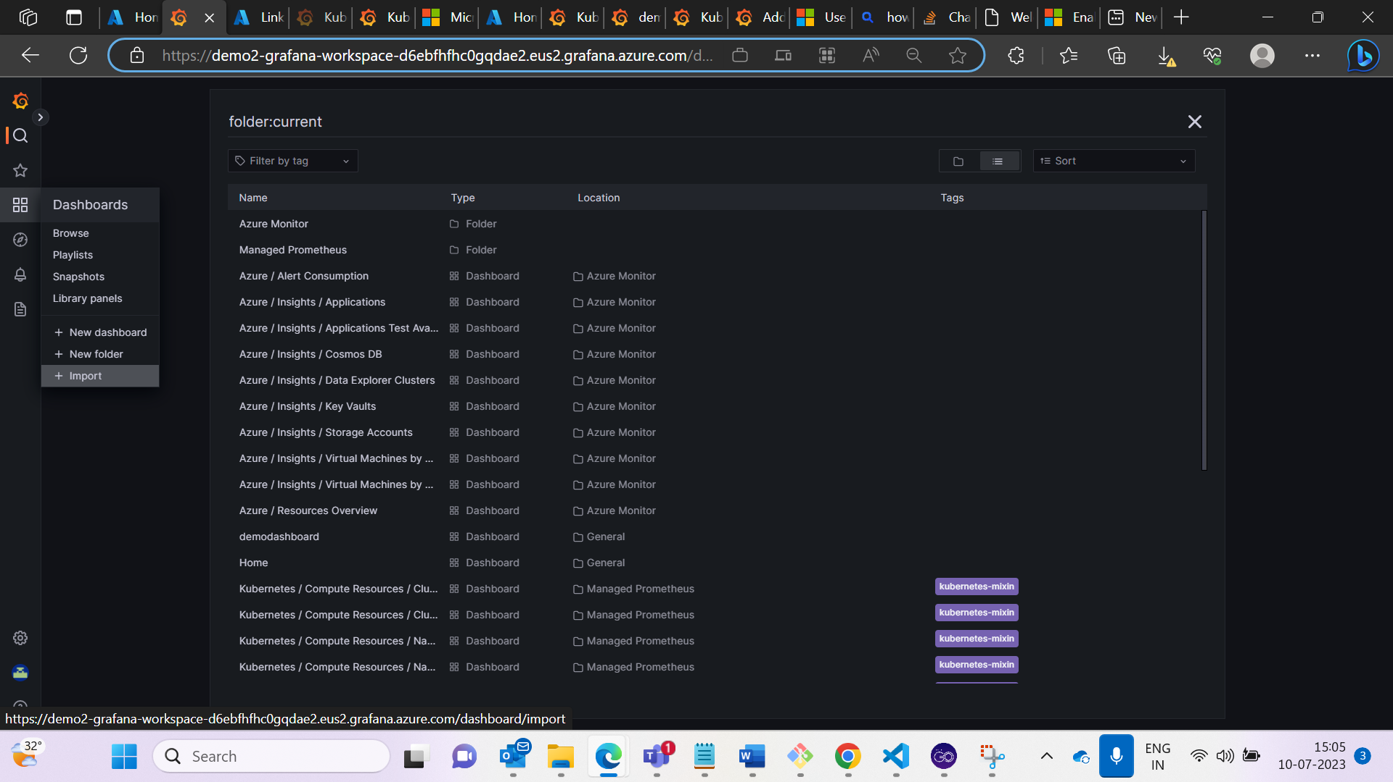

* Click on import and Upload saved file > Load.

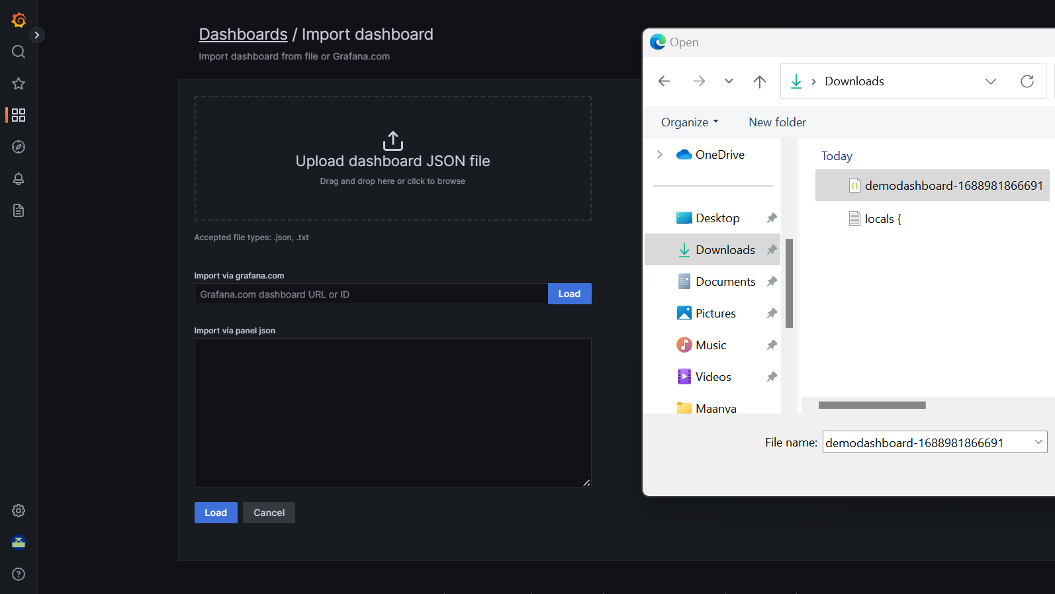

* You can see now the dashboard Imported successfully in other cluster.

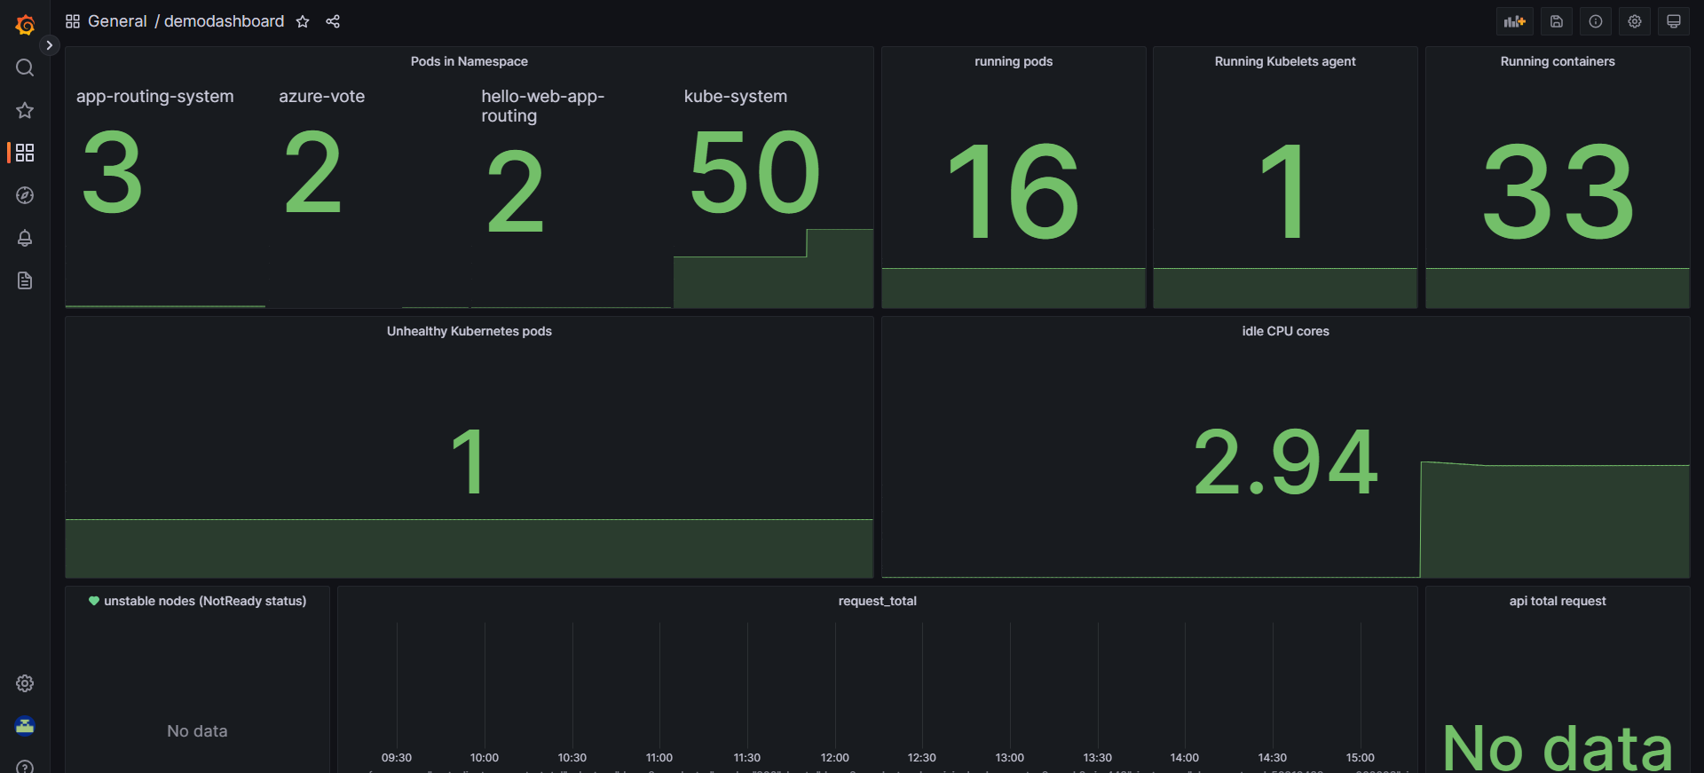

**3.5 Create the Alerts in the Grafana Dashboard**

* Creating the Alerts in Grafana dashboard:
* On the Navigator click on Alerting chose the data source and query that you want to set the alert.

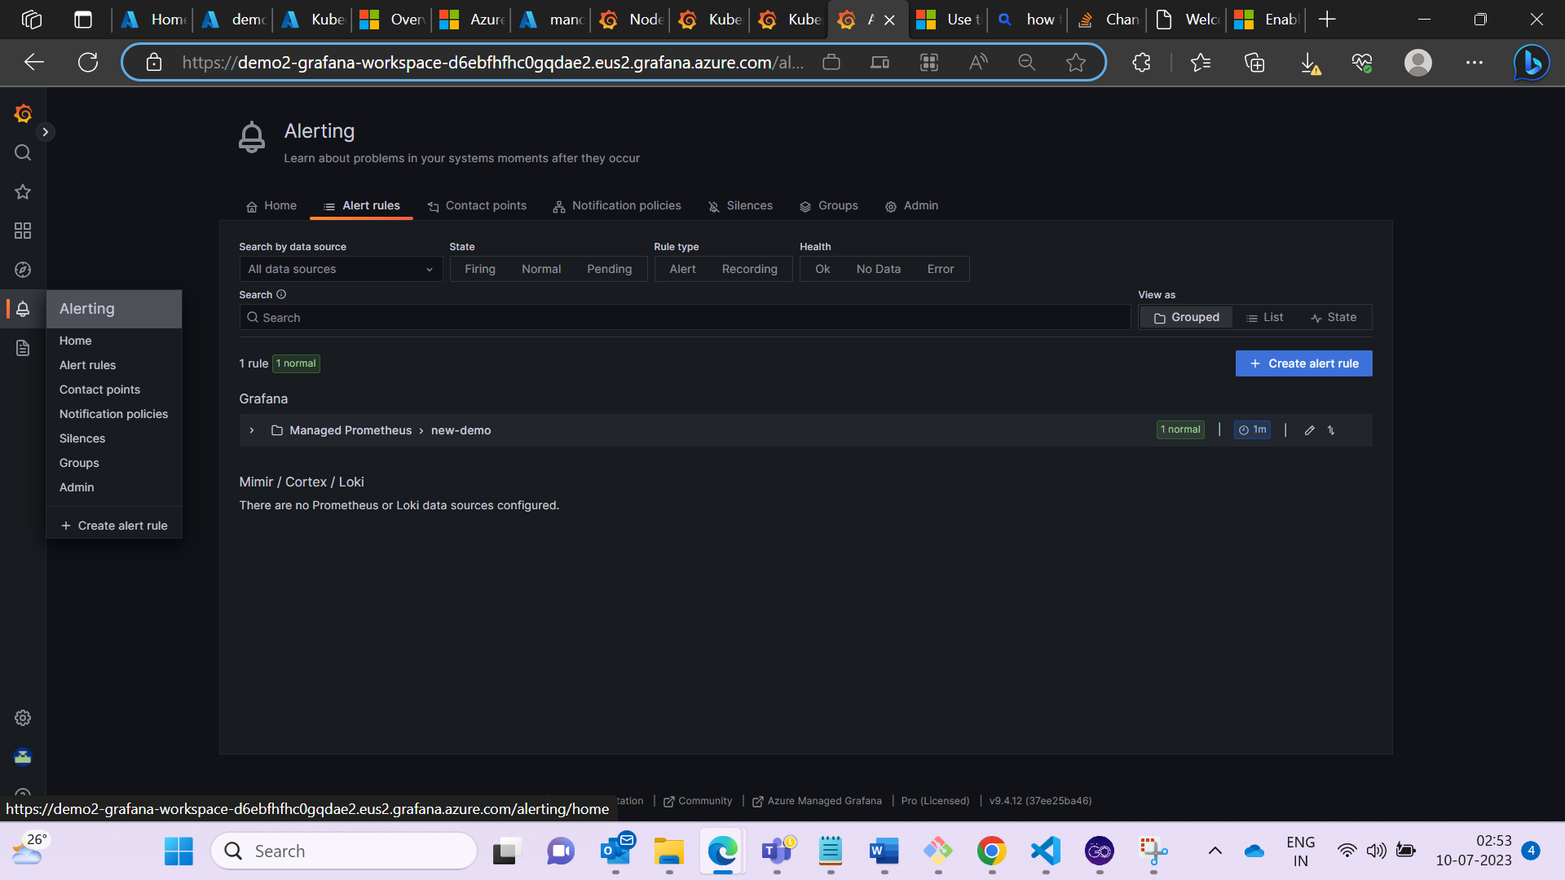

* Set the threshold for the metrics and set the alert.

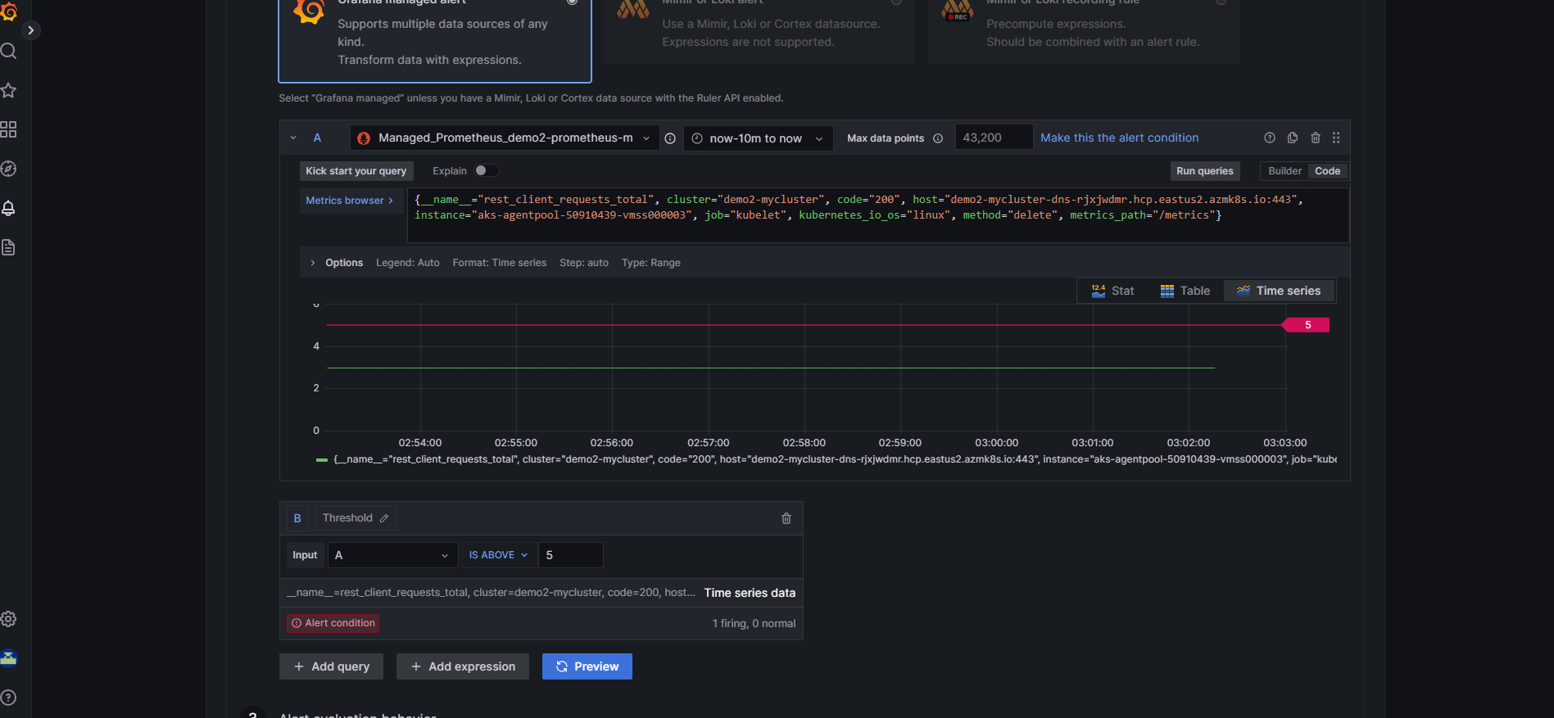

* Now the Alert is set successfully.

**4. Unified Grafana Dashboard.**

* 1. **Visualizing the metrics in same subscription same region of monitoring workspace.**

Subsciption1: AKS Cluster and Azure Monitoring Workspace in Southcentral region.

Subscription1: Azure Grafana Workspace in East US

* Created the mycluster1 in South central region.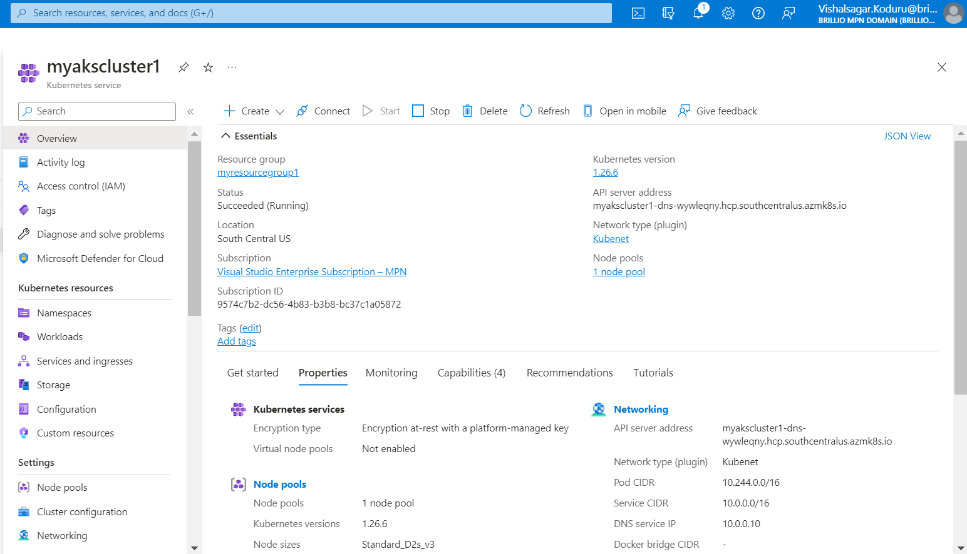
* Created the azure monitor workspace in South central region. 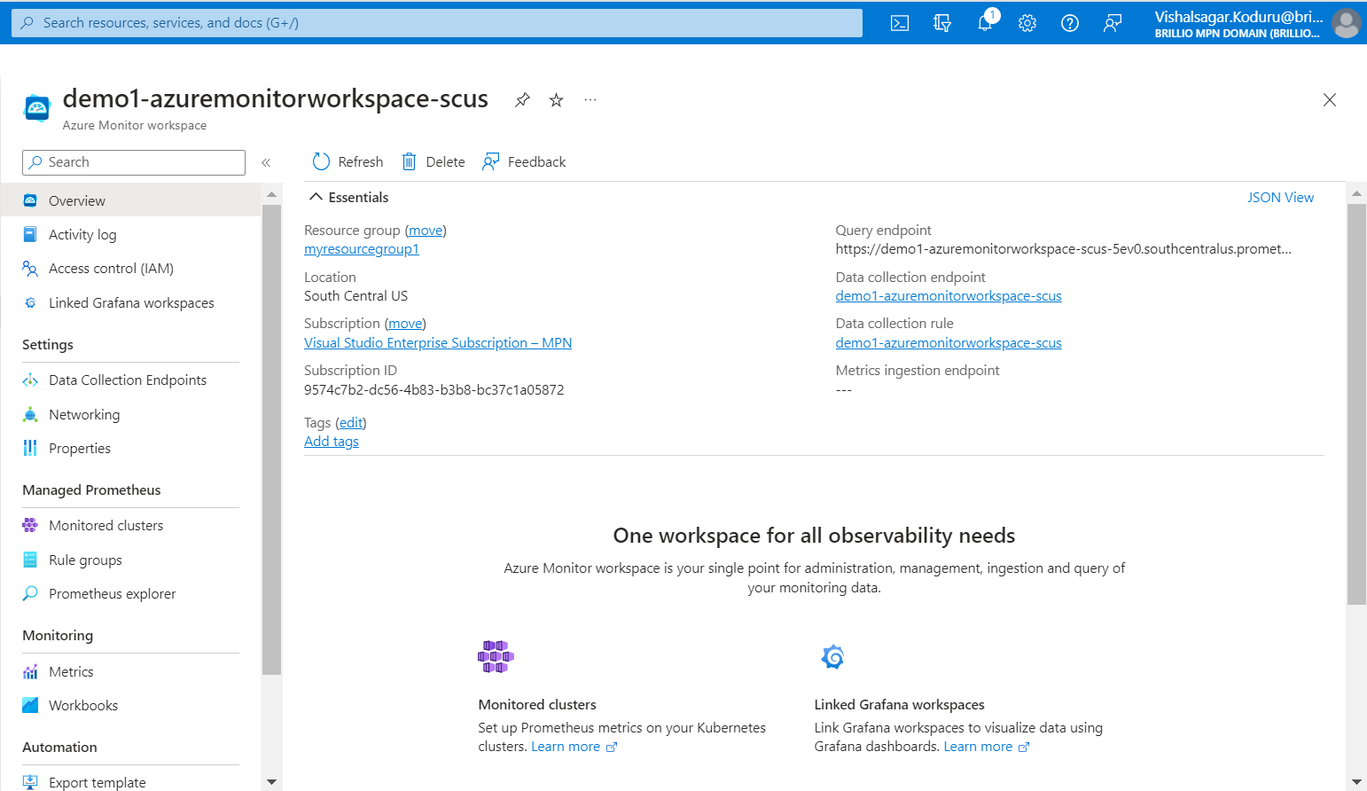
* Created Grafana workspace is in EastUS (different region).

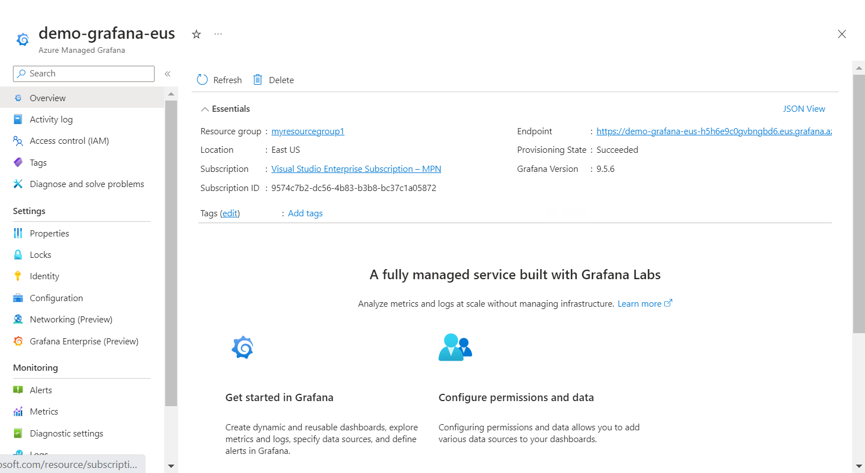

* Although the Azure Monitor workspace and the Grafana are in different regions, Still, we are able to visualize the metrics in the Grafana dashboard.

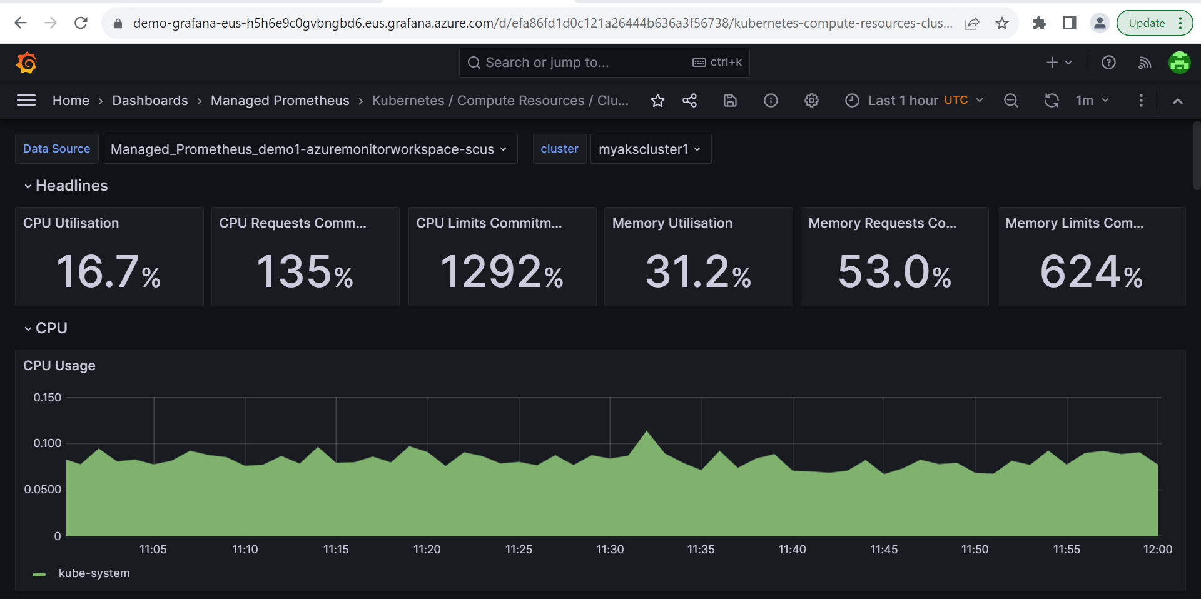

* 1. **Visualizing the metrics in same subscription different region of monitoring workspace**

Subscription1: AKS Cluster and Azure Grafana Workspace in East US region.

Subscription1: Azure Monitoring Workspace in Southcentral region.

* Created myakscluster in EastUS region.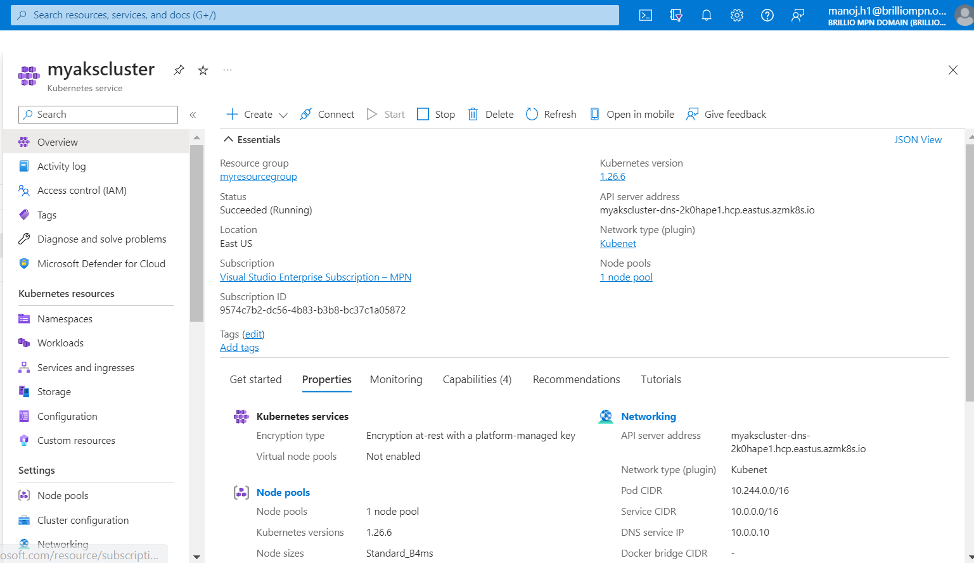
* Created the Monitor workspace in South central US region.



* Created Grafana workspace is in EastUS.



* Although the Azure monitoring workspace and cluster are in different region, still we can be able to view the metrics in Grafana.

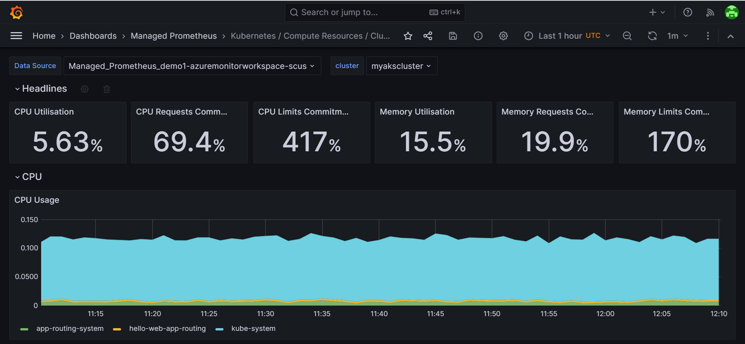

* 1. **Visualizing the metrics in different subscription.**

Subsciption2: AKS Cluster and Azure Monitoring Workspace in East US.

Subscription1: Azure Grafana Workspace in East US

By using the App registration or Managed Identity we can generate the connection between the Azure monitoring workspace (subscription2) to Azure Managed Grafana (subscription 1).

**Role Assignment using Managed Identity for Grafana workspace.**  
 Use the following steps to allow access all Azure Monitor workspaces in a subscription:

1. Open the **Identity** page for your Grafana workspace in the Azure portal.
2. If **Status** is **No**, change it to **Yes**.
3. Select **Azure role assignments** to review the existing access in your subscription.

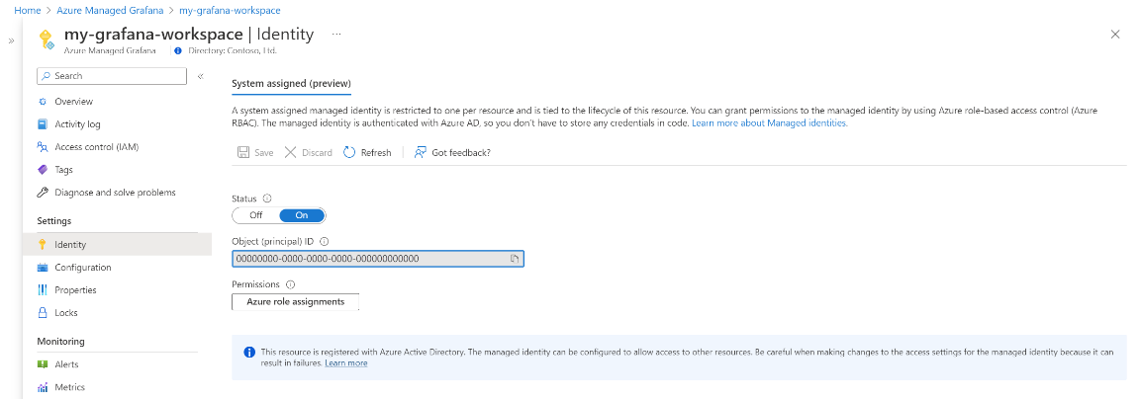

1. If **Monitoring Data Reader** isn't listed for your subscription or resource group:
   * 1. Select **+ Add role assignment**.
     2. For **Scope**, select other **Subscription where the Azure Monitor workspace is configured**.
     3. For **Role**, select **Monitoring Data Reader**.

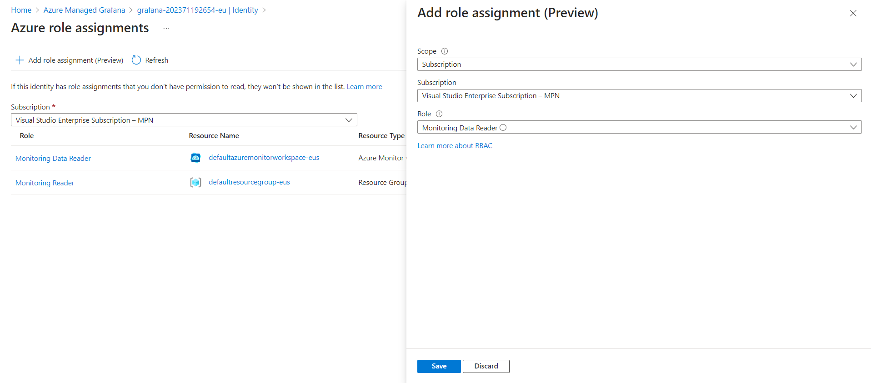

* + 1. Select **Save**,

**Role Assignment using managed Identity for Azure Monitor workspace.**

Use the following steps to allow access to allow Azure Grafana workspace In a subscription:

1. Open the **Access Control (IAM)** page for your Azure Monitor workspace in the Azure portal.



1. Select **Add role assignment**.
2. Select **Monitoring Data Reader** and select **Next**.



1. For **Assign access to**, select **Managed identity**.
2. In Subscription, select other **Subscription where the Azure Grafana workspace is configured**.
3. For **Managed identity**, select **Azure Managed Grafana**.
4. Select your Grafana workspace and then select **Select**.



1. Select **Review + assign** to save the configuration.

* Created the AKS-Cluster-subscription2 in different subscription (Subscription2).

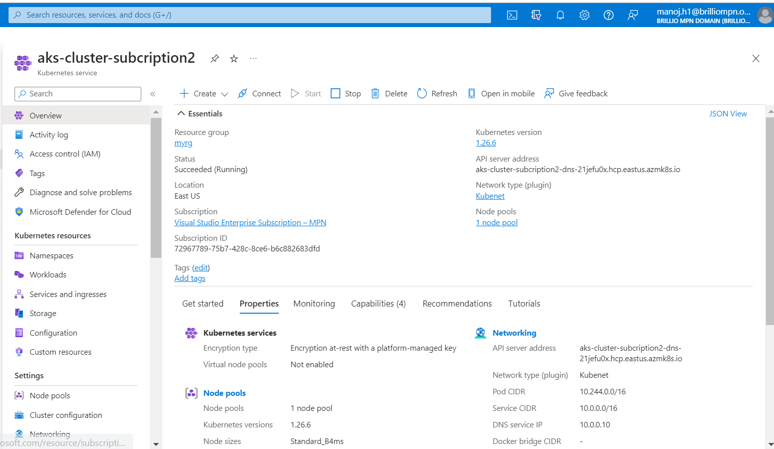

* Created Monitoring Workspace in the different subscription (subscription2)

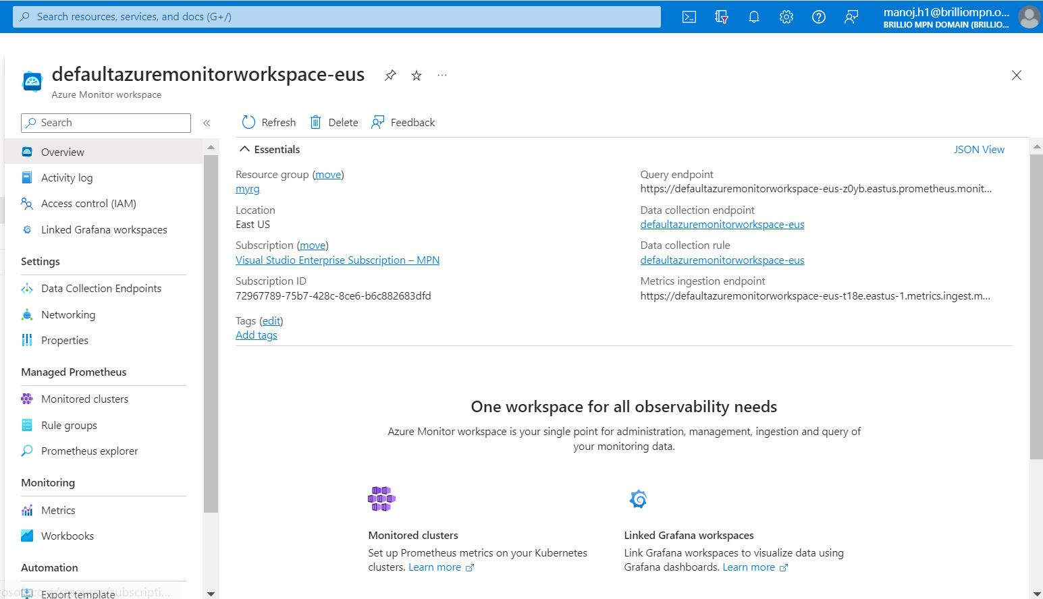

The below shows the Grafana resource in the subscription1.



Although azure monitoring workspace and the Grafana are in different subscription still we can be able to view the metrics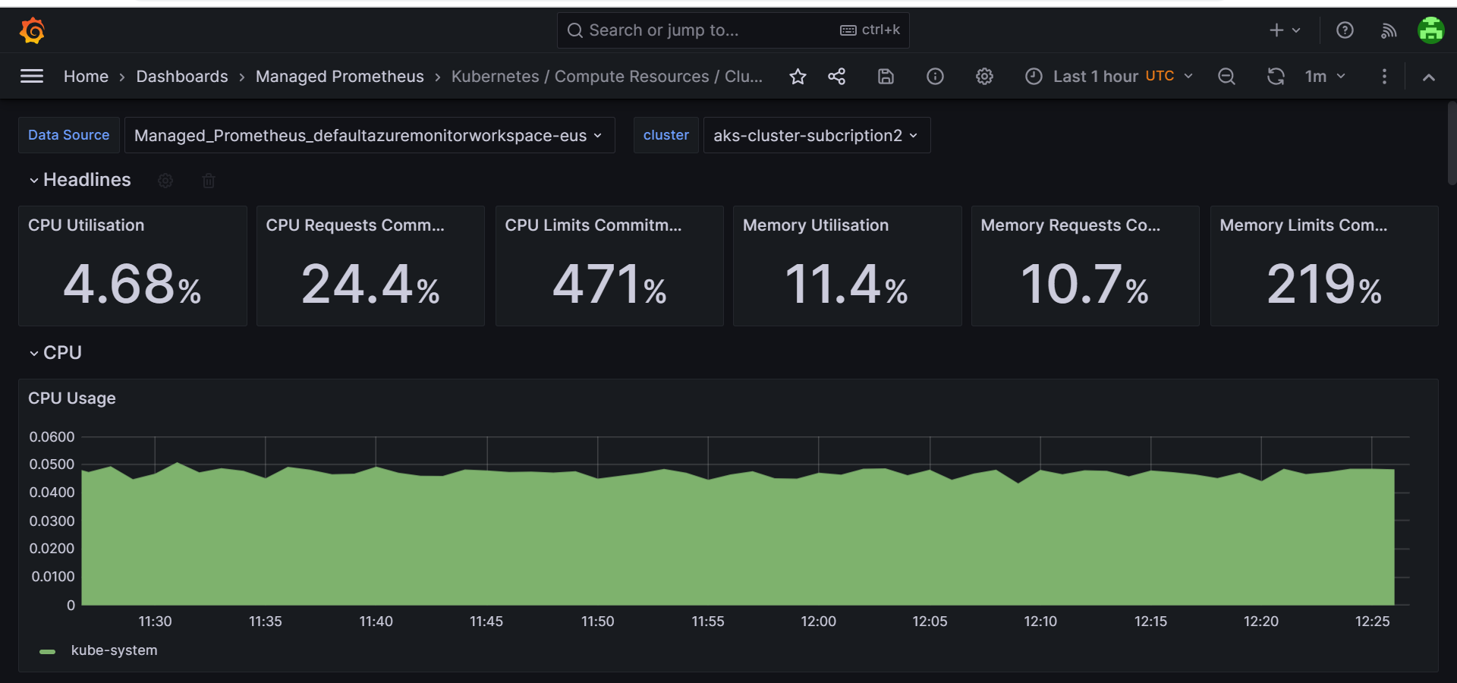

1. **References.**
2. [Use Azure Monitor managed service for Prometheus as data source for Grafana - Azure Monitor | Microsoft Learn](https://learn.microsoft.com/en-us/azure/azure-monitor/essentials/prometheus-grafana)
3. [Configure self-hosted Grafana to use Azure Monitor managed service for Prometheus as data source using Azure Active Directory. - Azure Monitor | Microsoft Learn](https://learn.microsoft.com/en-us/azure/azure-monitor/essentials/prometheus-self-managed-grafana-azure-active-directory)
4. [Metrics in Azure Monitor - Azure Monitor | Microsoft Learn](https://learn.microsoft.com/en-us/azure/azure-monitor/essentials/data-platform-metrics)